**S3 Block 5 Blue Revision Sheet**

**Non-Calculator**

**1.** Calculate : **(a)** 45.38 – 7.6 + 8.71 **(b)**  **(c)**  **(d)**  of 720 kg

**2. a)** How long is it from 12:48pm to 15:33pm?

**b)** A show lasts for 2 hrs 37 mins. If it starts at 18: 25 when does it finish?

**3.** Find 35% of 230 litres.

**4.** Find the mean of these numbers 4, 6, (-2), 8, (-1)

**5.** **a)** A circle has a diameter of 5m. What is its radius?

**b)** A circle has a radius of 12.6mm. What is its diameter?

**6.** **a)** Write 894 million in scientific notation.

**b)** Write 7.6 x 10-4 in scientific notation.

**7.** Starting with the smallest put the following in order: 0.707, 3/4, 76%, 0.07, 7/10

**8.** 210g of grass seed covers 3m2. How much grass seed is needed to cover 2.5m2 ?

**Calculator**

**1.** If the exchange rate is £1 = 1.43 Euros. Change

**a)** £400 to Euros. **b)** 235 Euros to pounds

**2.** **a)** Calculate the distance travelled in 2 hours 15 mins at a speed of 54 km/hr.

**b)** How long does a journey take in hrs and mins travelling at a speed of 65km/hr for 279.5 km?

**3.** How much interest is gained after 3 months on £1860 invested in a bank with an interest rate of 6.5% per annum?

**4.** **a)** Jack is paid an hourly rate of £12.70 and he works a 35 hour week. What is the annual basic pay?

**b)** What is Jack’s hourly overtime rate of pay if this is paid at time-and-a-half?

**5.** Claire takes out a buildings insurance policy for £170 000.

The annual premium is £1.40 for every £1000 of the building insurance policy.

**a)** How much does the annual premium cost Claire?

**b)** She wishes to pay this premium in weekly instalments. How much is this per week?

|  |  |
| --- | --- |
| France | 6 people |
| Italy | 5 people |
| Spain | 12 people |
| UK | 10 people |
| USA | 7 people |

**6.** A group of people were asked their holiday destinations.

If a pie chart were drawn of this data then what size

of angle should be used for each destination?

**7.** Find the missing values A,B,C,D and E

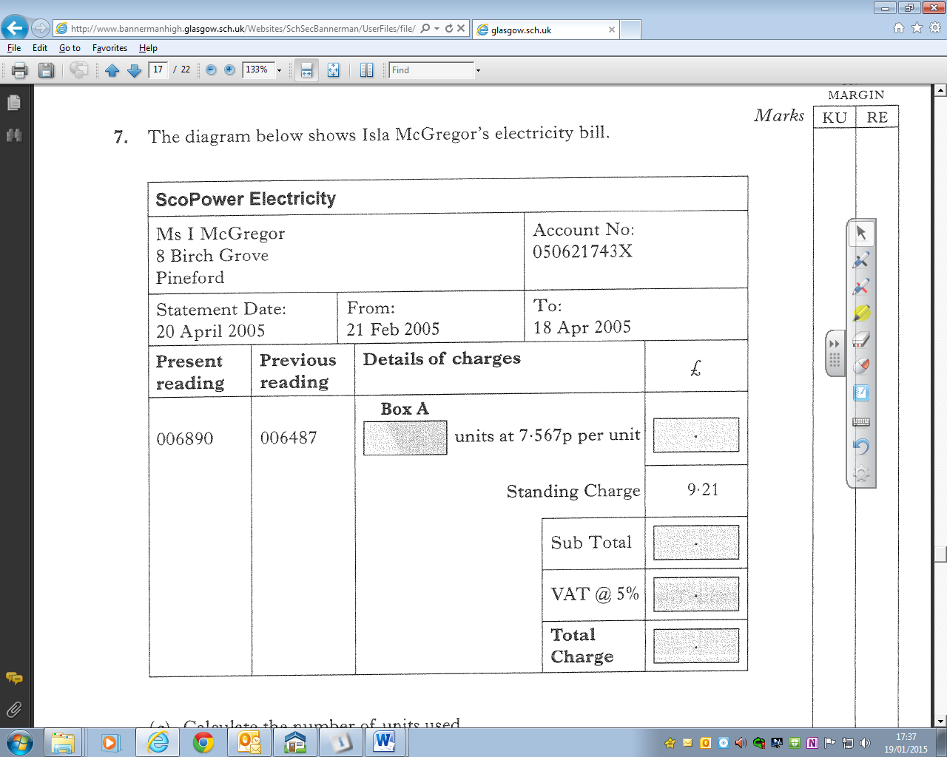

**Box B**

6.583p

007980

007465

8.74

**Box D**

**Box C**

**Box E**

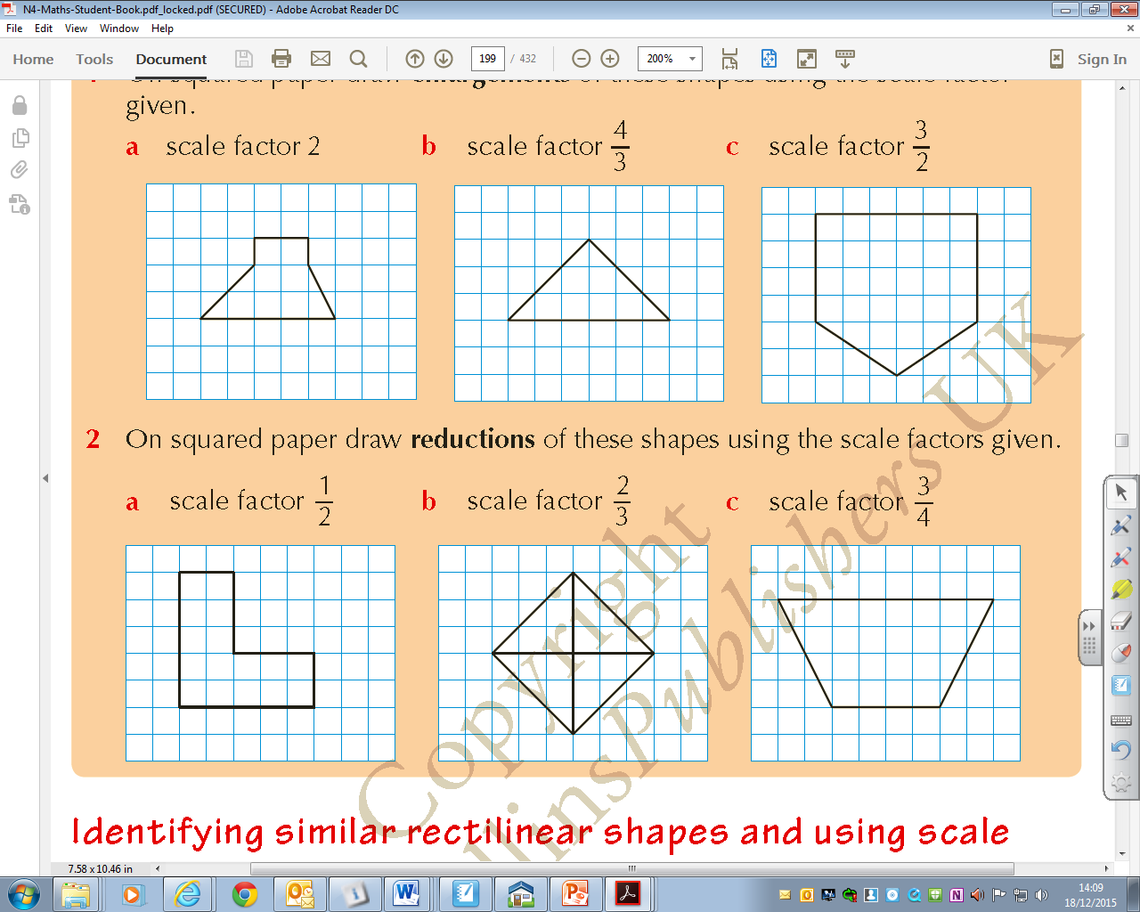**8.** Draw an enlargement of this shape using a scale factor of 2.

**Box E**