

**S2 Block 4 Revision Sheet (Sets 2&3)**

**Non-Calculator**

1. Calculate 9.4 – 4 x 1.9
2. Calculate a)  b) 2  1
3. Find the value of the following expressions when x = 4 and y = - 7

a) 8y b) 3x + y c) 3x2 – 2y

1. Solve a) 9x – 7 = 20 b) 5x – 4 = 2x + 11
2. Expand and simplify, as far as possible:- 4 ( 3m - 2 ) – 5 ( m - 3 )
3. The perimeter of the rectangle shown is 20 m.

x

a) Form an equation and solve it to find the value of x

3x + 2

b) Calculate the area of the rectangle

**7.** A car park has red, blue and green cars in the ratio 5 : 6 : 3

If there are 240 blue cars, how many cars are in the car park?

**8.** Calculate (a) 35% of 180kg (b) 62 % of 22ml

y

**9**. (a) What is the equation of this line?

(4,12)

(b) If the point (a , 36) lies on this line what is the value of a ?

(1,3)

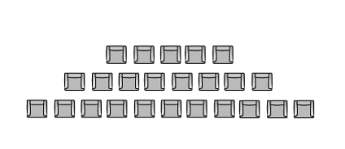

x

**10.** The diagram shows the number of seats in each row in a cinema.

(a) There are 5 in the front row, 8 in the second row, 11 in the third row and so on.

Copy and complete the table:

Row (R) 1 2 3 4 5 6

Number seats in row (S) 5 8 ? ? ? ?

(b) Write down a formula for finding the number of seats if you know the number of rows.

(c) How many seats would be in 19 rows?

(d) A cinema has been made with 188 seats. How many rows are there?



**S2 Block 4 Revision Sheet (Sets 2&3)**

**Calculator**

1.A shop keeper bought 200 hats for £800 and sold each for £5.75 each.  
Calculate (a) the total profit (b) the percentage profit .

2. A dry fertilizer mix uses calcium, carbon and nitrogen in the ratio **3:4:2**

(a) If a farmer orders 120kg of calcium, how many kgs of carbon and nitrogen are needed?

(b) A single batch of dry fertiliser weighs 90 kg. How many batches can the farmer spread?

(c) It is estimated that water needs to be added to the dry mix in the ratio (dry mix to water) **8:1.**

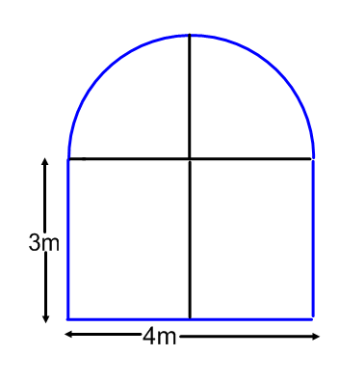

How many litres of water should be mixed in? (1 litre of water weighs exactly 1 kg)

3.A glass table with a quarter circle end is made to the following specification.  
 (a) Calculate the area of glass required in .  
 (b) Glass is bought in quantities of 0.1 

(i) Round your answer in (a) to 1 decimal place.

5m

(ii) How much would the glass cost if it costs £36.50 per m2 ?

2m

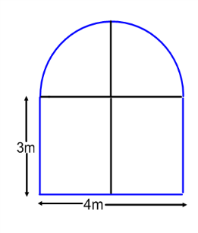4.A church window is in the shape of a rectangle with a semi-circle at one end.

The Lead around the perimeter of the window is to be replaced.

The width of the window is 800 millimetres and the overall height is 3.8 metres  
 (a) What is the width of the window in metres ?  
 (b) Calculate the length of lead needed, **correct to 3 significant figures.**

3.8m

800mm

1. An oil tank is in the shape of a cuboid of length 1.4 metres, breadth 1.3 metres and height 87cm.  
    How many litres of oil are in the tank when full?
2. Tins of beans come in cylindrical tins 13 cm high and with a diameter of 5 cm.  
   These tins are packed into boxes of length 35 cm, breadth 30 cm and height 26 cm.

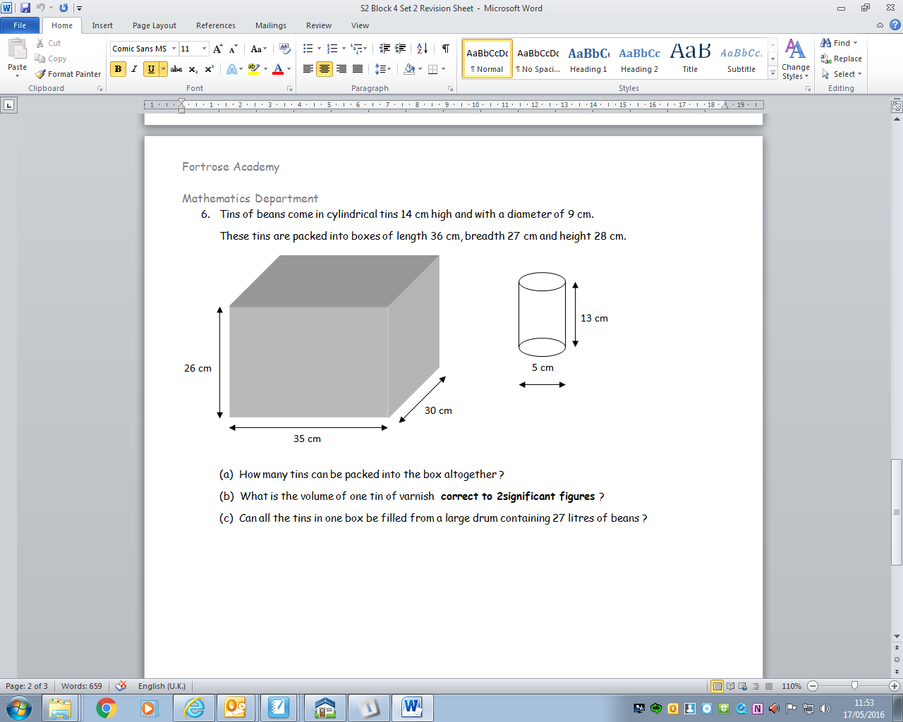

(a) How many tins can be packed into the box altogether?  
(b) What is the volume of one tin of varnish **correct to 2significant figures** ?  
(c) Can all the tins in one box be filled from a large drum containing 27 litres of beans ?