Numeracy Across Learning

Focus – CfE Level 3 Numeracy Outcomes

Fortrose Academy



2012

Acknowledgements:

With thanks to Edinburgh City Council and John Gillespie High School for their support in using their materials within this booklet particular thanks to Justine Haddow, the teacher at John Gillespie High School, who produced them.
Contents:
Page:

Introduction
- Aims of Booklet 7
- How to use this Booklet 7
- Other Supporting Information 7
1. Estimation & Rounding 8

- Experiences & Outcomes 8
(MNU 301a)
- How this is taught 9
  - Estimation for calculations 9
  - Rounding Whole Numbers 10
  - Rounding to Decimal Places 10
  - Rounding to Significant Figures 11

- Key Words 12
2. Number & Number Processes 13

- Experiences & Outcomes 13
(MNU 303a, MNU 303b, MNU 304a)
- How this is taught
  - Addition: Mental Strategies 15
Written Methods 15
  - Subtraction: Mental Strategies 16
Written Methods 16
  - Multiplication: Mental Strategies 17
Multiplying by 10 & 100 18
  - Division: Written Methods 19
  - Order of Operations: BOMDAS 20
  - Negative Numbers 22

- Key Words 24

3. Fractions, Decimals & Percentages 26

- Experiences & Outcomes 26
(MNU 307a, MNU 308a)
- How this is taught: 27
  - Fractions Equivalent fractions 27
Simplifying fractions 27
Calculating fractions of quantity 28

  - Decimal Fractions 28

  - Percentages Without a calculator 29
With a calculator 32
Finding a percentage 33

  - Ratio Writing ratios 34
Simplifying ratios 34
Using ratios 35
Sharing in a given ratio 36
  - Proportion 37

- Key Words 38

4. Money 40

- Experiences & Outcomes 40
(MNU 309a, MNU 309b)
- How this is taught 41
  - Decimal places and money 41
  - Budgeting 42
  - Sale Prices & Offers 43
% Discounts 43
BOGOF deals 45
% extra free deals 45
3 for the price of 2 deals 45
  - VAT with and without a calculator 47-48
  - Hire Purchase 48
  - Loans 49
  - Savings accounts and % Interest rates 50
  - Interpreting bank statements 51

- Key Words 52
5. Time 53
- Experiences & Outcomes 53
(MNU 310a)
- How this is taught 54
  - Time notation 54
  - Time Periods 55
  - Distance, Speed & Time 55
  - Interpreting Timetables 56
  - Time, Decimals & Graphs 57

- Key Words 58

6. Measurement 59
- Experiences & Outcomes
(MNU 311a)
- How this is taught 60
  - Reading Scales 60
  - Conversions between units
Metric 60
Imperial 61
Conversion Graphs 62
Conversions: area & volume 62
  - Perimeter 63
  - Area
Rectangle 64
Triangle 64
Compound Shapes 65
Parallelogram 67
  - Volume 68
Cuboids 69
Other Prisms 70

- Key Words 72

7. Data & Analysis 73
- Experiences & Outcomes 73
(MNU 320a)
- How this is taught 74
  - Tables 74
  - Bar Graphs 75
  - Line Graphs 76
  - Scatter Graphs 77
  - Pie Charts 78
  - Averages 80
  - Stem & Leaf Diagrams 81

- Key Words 83

8. Idea of Chance & Uncertainty 84
- Experiences & Outcomes 84
(MNU 322a)
- How this is taught 85
  - Describing Probabilities 85
  - Finding Probabilities 85
  - Experimental Probabilities 87
  - Sum of Probabilities 88
  - Combined Events 89

- Key Words 91

9. Glossary of All Terms 92

Introduction

Aims of this booklet:
- To enable all teachers to adopt a common approach to teaching numeracy across the curriculum.
- To provide materials which will support non-mathematics teachers when delivering numeracy tasks within their subjects
- This will help pupils as they will more easily recognize the numeracy skills required for their work and will ensure consistency in the methods they will use.
- This will also help numeracy co-ordinators when collating evidence of pupil’s progress in numeracy
How to Use this Booklet:
- It is envisaged that Teachers will refer to this booklet in advance of teaching numeracy skills, retain it as a resource and ‘dip into’ the resources as and when necessary.
- The contents page can be used to find materials by topic and there is also a table in the back of the booklet to help you find the materials by the experience / outcome. There is also a reference made to the ‘numeracy links’ subject booklets.
- The booklet also highlights how ‘not’ to teach some aspects of numeracy and some of the language / terms which are no longer used. Please ensure that you Check the new methods, before delivery, so as not to confuse students.
- There are also hyperlinks you can use to get to specific pages quickly. To follow them hold down the ‘CTRL’ key and then ‘left click’ with the mouse.

Other Supporting Information:
- This booklet is to be used in conjunction with the Principles & Practice documents and the full Numeracy experiences & outcomes for the purposes of planning.
http://www.ltscotland.org.uk/curriculumforexcellence/responsibilityofall/numeracy/index.asp
- This booklet also complements the ‘Numeracy Links in..’ booklets issued to schools in May 2009. These can be found on Glow on the Eileanan Siar section.
https://portal.glowscotland.org.uk/establishments/eileanansiar/CfE2/default.aspx
Click on your subject tab and look in the documents section.

Please note that sections highlighted in green are skills that should be expected to be achieved at a level below Third Level.

Please note that sections highlighted in yellow are skills that should be expected to be achieved at a level above Third Level.
Estimation and rounding

Experiences & Outcomes:

Second Level | Third Level | Fourth Level
I can use my knowledge of rounding to routinely estimate the answer to a problem, then after calculating, decide if my answer is reasonable, sharing my solution with others.  MNU 2-01a | I can round a number using an appropriate degree of accuracy, having taken into account the context of the problem.  MNU 3-01a | Having investigated the practical impact of inaccuracy and error, I can use my knowledge of tolerance when choosing the required degree of accuracy to make real-life calculations.  MNU 4-01a

Estimation & Rounding:
Estimation for calculations
Rounding Whole Numbers
Rounding to Decimal Places
Rounding to Significant Figures

How this is taught: Estimation for calculations
Outcomes
Using rounding to estimate the answer to a Calculation

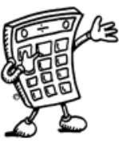
Example 1
Tickets for a concert were sold over 4 days. The number of tickets sold each day was recorded in the table below. How many tickets were sold in total?

Monday | Tuesday | Wednesday | Thursday
486 | 205 | 197 | 321

Estimate = 500 + 200 + 200 + 300 = 1200

Calculate:

Answer = 1209 tickets
Example 2
A bar of chocolate weighs 42g. There are 48 bars of chocolate in a box. What is the total weight of chocolate in the box?

Estimate = 50 x 40 = 2000g

Calculate:

Answer = 2016g
We can use rounded numbers to give us an approximate answer to a calculation. This allows us to check that our answer is sensible.

42
x48
336
1680
2016

486
205
197
+321
1209
42
x48
336
+ 1680
2016
How this is taught: Rounding Whole Numbers
Outcomes

Numbers can be rounded to give an approximation. We can either round up or down to get to the approximate value.
2652

2600 2610 2620 2630 2640 2650 2660 2670 2680 2690 2700

2652 rounded to the nearest 10 is 2650
2652 rounded to the nearest 100 is 2700
When rounding numbers which are exactly in the middle, convention is to round up.
7865 rounded to the nearest 10 is 7870.

In general, to round a number, we must first identify the place value to which we want to round. We must then look at the next digit to the right (the “check digit”) - if it is 5 or more round up.

Example 1 Round 46 753 to the nearest thousand.

6 is the digit in the thousands column - the check digit (in the
hundreds column) is a 7, so round up.

46 753
= 47 000 to the nearest thousand

How this is taught: Rounding to Decimal Places

Example 1 Round 1.57359 to 2 decimal places

The second number after the decimal point is a 7 - the check digit
(the third number after the decimal point) is a 3, so round down.

1.57359
= 1.57 to 2 decimal places
How this is taught: Rounding to Significant Figures
Outcomes

Numbers can also be rounded to a given number of significant figures.
To start counting the significant figures find the first non-zero number on the left hand side.

Example 1 The attendance at the cup final was 83 577. Round this to two significant figures.

The first significant figure is 8
The second significant figure is 3
8 3 5 7 7

1st 2nd
We then look at the next number and decide whether to round the 3 up or keep it the same. It is 5 so we round the 3 up to 4:
= 84 000 to 2 significant Figures

The same principle applies to rounding decimal numbers.

Example 2 Round 0.15273 to 2 significant figures

The first significant figure is 1 in the tenths place
The second significant figure is 5 in the hundredths place

0 . 1 52 7 3

1st 2nd
We then look at the next number and decide whether to round the 5 up or keep it the same. It is 2 so we keep the 5 the same

= 0 . 1 5 to 2 significant figures

Key Words:

Mathematical Dictionary (Key words):

Approximate | An estimated answer, often obtained by rounding to nearest 10, 100 or decimal place.
Equals (=) | Is the same as, makes or has the same amount as.
Estimate | To make an approximate or rough answer, often by rounding.
Place value | The value of a digit dependent on its place in the number.  Example: in the number 1573.4, the 5 has a place value  of 100.
Significant figures | The first non-zero figures in a number which give the most information about the size of the number.
Decimal places | Places to the right of the decimal point. The first number to the right is the first decimal place.
Number & Number Processes:
(including addition, subtraction, multiplication, division and negative numbers)

Experiences & Outcomes:

 | Second Level | Third Level | Fourth Level
Whole Numbers | I have extended the range of whole numbers I can work with and having explored how decimal fractions are constructed, can explain the link between a digit, its place and its value.  MNU 2-02a  Having determined which calculations are needed, I can solve problems involving whole numbers using a range of methods, sharing my approaches and solutions with others.  MNU 2-03a  I have explored the contexts in which problems involving decimal fractions occur and can solve related problems using a variety of methods.  MNU 2-03b  I can show my understanding of how the number line extends to include numbers less than zero and have investigated how these numbers occur and are used.  MNU 2-04a | I can use a variety of methods to solve number problems in familiar contexts, clearly communicating my processes and solutions.  MNU 3-03a  I can continue to recall number facts quickly and use them accurately when making calculations.  MNU 3-03b  I can use my understanding of numbers less than zero to solve simple problems in context.  MNU 3-04a | Having recognised similarities between new problems and problems I have solved before, I can carry out the necessary calculations to solve problems set in unfamiliar contexts.  MNU 4-03a
Number Processes
Negative Numbers

Number & Number Processes:

Whole Numbers: Pupils are expected to be able to work with decimals & fractions beyond the Second Level.

Number Processes:

Addition: Mental Strategies
Written Methods

Subtraction: Mental Strategies
Written Methods

Multiplication: Mental Strategies
Multiplying by 10 & 100

Division: Written Methods

Order of Calculation: BOMDAS

Negative Numbers: Addition, Subtraction, Multiplication, Division

Key Words:

How this is taught: Addition
Outcomes
Mental strategies

Example Calculate 54 + 27

Method 1 Add tens, then add units, then add together

50 + 20 = 70 4 + 7 = 11 70 + 11 = 81

Method 2 Split up number to be added into tens and units and add separately.

54 + 20 = 74 74 + 7 = 81

Method 3 Round up to nearest 10, then subtract

54 + 30 = 84 but 30 is 3 too much so subtract 3;
84 - 3 = 81

Written Method
When adding numbers, ensure that the numbers are lined up according to place value. Start at right hand side, write down units, carry tens.

Example Add 3032 and 589

3032 3032 3032 3032
+589 +589 +589 +589
1 21 621 3621

There are a number of useful mental strategies for addition. Some examples are given below.
2 + 9 = 11
3+8+1=12
0+5+1=6
3 + 0 = 3
1

1 1
1 1

1 1

How this is taught: Subtraction
Outcomes

Mental Strategies

Example Calculate 93 - 56

Method 1 Count on

Count on from 56 until you reach 93. This can be done in several ways
e.g.

4 30 3 = 37

56 60 70 80 90 93

Method 2 Break up the number being subtracted

e.g. subtract 50, then subtract 6 93 - 50 = 43
43 - 6 = 37
6 50

37 43 93

Written Method
Example 1 4590 – 386 Example 2 Subtract 692 from 14597

We use decomposition as a written method for subtraction (see below). Alternative methods may be used for mental calculations.

4590
- 386
4204
14597
- 692
13905
8 1
3 1
We do not “borrow and pay back”.
Start
How this is taught: Multiplication of Whole Numbers
Outcomes

x | 1 | 2 | 3 | 4 | 5 | 6 | 7 | 8 | 9 | 10 | 11 | 12
1 | 1 | 2 | 3 | 4 | 5 | 6 | 7 | 8 | 9 | 10 | 11 | 12
2 | 2 | 4 | 6 | 8 | 10 | 12 | 14 | 16 | 18 | 20 | 22 | 24
3 | 3 | 6 | 9 | 12 | 15 | 18 | 21 | 24 | 27 | 30 | 33 | 36
4 | 4 | 8 | 12 | 16 | 20 | 24 | 28 | 32 | 36 | 40 | 44 | 48
5 | 5 | 10 | 15 | 20 | 25 | 30 | 35 | 40 | 45 | 50 | 55 | 60
6 | 6 | 12 | 18 | 24 | 30 | 36 | 42 | 48 | 54 | 60 | 66 | 72
7 | 7 | 14 | 21 | 28 | 35 | 42 | 49 | 56 | 63 | 70 | 77 | 84
8 | 8 | 16 | 24 | 32 | 40 | 48 | 56 | 64 | 72 | 80 | 88 | 96
9 | 9 | 18 | 27 | 36 | 45 | 54 | 63 | 72 | 81 | 90 | 99 | 108
10 | 10 | 20 | 30 | 40 | 50 | 60 | 70 | 80 | 90 | 100 | 110 | 120
11 | 11 | 22 | 33 | 44 | 55 | 66 | 77 | 88 | 99 | 110 | 121 | 132
12 | 12 | 24 | 36 | 48 | 60 | 72 | 84 | 96 | 108 | 120 | 132 | 144

Mental Strategies

Example Find 39 x 6

Method 1

Method 2
It is essential that you know all of the multiplication tables from 1 to 12. These are shown in the tables square below.

30 x 6
= 180
9 x 6
= 54
180 + 54
= 234
40 x 6
=240
40 is 1 too many so take away 6x1
240 - 6
= 234
How this is taught: Multiplication
Outcomes
Multiplying by multiples of 10 and 100

Example 1 (a) Multiply 354 by 10 (b) Multiply 50.6 by 100

Th H T U Th H T U • t

354 x 10 = 3540 50.6 x 100 = 5060

(c) 35 x 30 (d) 436 x 600

35 x 3 = 105 436 x 6 = 2616
105 x 10 = 1050 2616 x 100 = 261600

so 35 x 30 = 1050 so 436 x 600 = 261600

For division do the reverse

Example 2 (a) 2.36 x 20 (b) 38.4 x 50

2.36 x 2 = 4.72 38.4 x 5 = 192.0
4.72 x 10 = 47.2 192.0x 10 = 1920

so 2.36 x 20 = 47.2 so 38.4 x 50 = 1920

To multiply by 10 you move every digit one place to the left.
To multiply by 100 you move every digit two places to the left.
We may also use these rules for multiplying decimal numbers.
3 5 4 5 0 • 6
3 5 4 0 5 0 6 0 • 0
To multiply by 30, multiply by 3, then by 10.
To multiply by 600, multiply by 6, then by 100.
Division
Outcomes

Written Method

Example 1 There are 192 pupils in first year, shared equally between
8 classes. How many pupils are in each class?

2 4
8 1 9³2 There are 32 pupils in each class

Example 2 Divide 4.74 by 3

1 . 5 8
3 4 . ¹7²4

Example 3 A jug contains 2.2 litres of juice. If it is poured evenly
into 8 glasses, how much juice is in each glass?

0 . 2 7 5
8 2 .²2⁶0⁴0

Each glass contains
0.275 litres
You should be able to divide by a single digit or by a multiple of 10 or 100 without a calculator.

When dividing a decimal number by a whole number, the decimal points must stay in line.
If you have a remainder at the end of a calculation, add a zero onto the end of the decimal and continue with the calculation.
Order of Calculation (BODMAS)
Outcomes
Consider this: What is the answer to 2 + 5 x 8 ?

Is it 7 x 8 = 56 or 2 + 40 = 42 ?

The correct answer is 42.

The BODMAS rule tells us which operations should be done first. BODMAS represents:

Scientific calculators use this rule, some basic calculators may not, so take care in their use.

Example 1 15 – 12 ÷ 6 BODMAS tells us to divide first
= 15 – 2
= 13

Example 2 (9 + 5) x 6 BODMAS tells us to work out the
= 14 x 6 brackets first
= 84

Example 3 18 + 6 ÷ (5-2) Brackets first
= 18 + 6 ÷ 3 Then divide
= 18 + 2 Now add
= 20

Calculations which have more than one operation need to be done in a particular order. The order can be remembered by using the mnemonic BODMAS
(B)rackets
(O)f
(D)ivide
(M)ultiply
(A)dd
(S)ubract
Evaluating Formulae:
This will usually be encountered in Maths lessons at first but more able pupils may go on to use these rules when calculating values from formulae at Third & Fourth Levels in a few subject areas.
Outcomes

Example 1

Use the formula P = 2L + 2B to evaluate P when L = 12 and B = 7.

P = 2L + 2B Step 1: write formula
P = 2 x 12 + 2 x 7 Step 2: substitute numbers for letters
P = 24 + 14 Step 3: start to evaluate (BODMAS)
P = 38 Step 4: write answer

Example 2

Use the formula I = 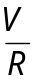 to evaluate I when V = 240 and R = 40

I =
I = 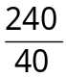
I = 6

Example 3

Use the formula F = 32 + 1.8C to evaluate F when C = 20

F = 32 + 1.8C
F = 32 + 1.8 x 20
F = 32 + 36
F = 68
To find the value of a variable in a formula, we must substitute all of the given values into the formula, then use BODMAS rules to work out the answer.

Negative Numbers:

Addition & Subtraction:
. Using a number line:

To add and subtract numbers always begin counting from zero.
When dealing with positive numbers count to the right.
When dealing with negative numbers count to the left.

e.g. Calculate 4 - 5 - 3
- 3 -5

-10 -9 -8 -7 -6 -5 -4 -3 -2 -1 0 1 2 3 4 5 6 7 8 9

Start at 4
Move 5 places to the left (- 5)
Move 3 places to the left (- 3)

Answer: - 4
When adding or subtracting negative numbers, we must remember that when two signs appear next to each other and are different, then we subtract. When two signs are next to each other and they are the same, we add:

i.e.
}+ }-
_ _
_ +
+ ⁺
+ _

For example:

Calculate: Solutions:
a) 10 + (⁻ 7) = 10 - 7 = 3
b) 4 – (⁻3) = 4 + 3 = 7
a) 10 + (⁻ 7)
b) 4 – (⁻ 3)
Multiplying and dividing negative numbers
The rule for multiplying and dividing is very similar to the rule for adding and subtracting. When the signs are different the answer is negative and when the signs are the same the answer is positive:
}- -
}+
+ X - + X +
- X + - X –
+ ÷ - + ÷ +
- ÷ + - ÷ -

For example:

Calculate: Solution:
- 5 x (⁻4)
b) (⁻40) ÷ (⁻8)
- We have ⁺5 and ⁻4. The signs are different, so the answer will be negative. So, ⁺5 x (⁻4) = ⁻20

- We have ⁻40 and ⁻8. The signs are the same, so the answer will be positive. So, ⁻40 ÷ (⁻8) = 5
Key Words:

Mathematical Dictionary (Key words):

Add; Addition (+) | To combine 2 or more numbers to get one number (called the sum or the total)  Example: 12+76 = 88
Calculate | Find the answer to a problem. It doesn’t mean that you must use a calculator!
Difference (-) | The amount between two numbers (subtraction).  Example: The difference between 50 and 36 is 14  50 – 36 = 14
Division (÷) | Sharing a number into equal parts.  24 ÷ 6 = 4
Double | Multiply by 2.
Equals (=) | Makes or has the same amount as.
Evaluate | To work out the answer.
Even | A number that is divisible by 2.  Even numbers end with 0, 2, 4, 6 or 8.
Factor | A number which divides exactly into another number, leaving no remainder.  Example: The factors of 15 are 1, 3, 5, 15.
Greater than (>) | Is bigger or more than.  Example: 10 is greater than 6.  10 > 6
Least | The lowest number in a group (minimum).
Less than (<) | Is smaller or lower than.  Example: 15 is less than 21. 15 < 21.
Maximum | The largest or highest number in a group.
Minimum | The smallest or lowest number in a group.
Minus (-) | Subtract or a negative number
Most | The largest or highest number in a group (maximum).
Multiple | A number which can be divided by a particular number, leaving no remainder.  Example Some of the multiples of 4 are 8, 16, 48, 72
Multiply (x) | To combine an amount a particular number of times.  Example 6 x 4 = 24
Negative Number | A number less than zero. Shown by a minus sign.  Example -5 is a negative number.
Odd Number | A number which is not divisible by 2.  Odd numbers end in 1 ,3 ,5 ,7 or 9.
Operations | The four basic operations are addition, subtraction, multiplication and division.
Order of operations | The order in which operations should be done. BOMDAS (see p9)
Place value | The value of a digit dependent on its place in the number.  Example: in the number 1573.4, the 5 has a place value  of 100.
Prime Number | A number that has exactly 2 factors (can only be divided by itself and 1). Note that 1 is not a prime number as it only has 1 factor.
Product | The answer when two numbers are multiplied together.  Example: The product of 5 and 4 is 20.
Remainder | The amount left over when dividing a number.
Share | To divide into equal groups.
Sum | The total of a group of numbers (found by adding).
Total | The sum of a group of numbers (found by adding).

Fractions, decimal fractions and percentages:

(including ratio and proportion)

Experiences & Outcomes:

Second Level | Third Level | Fourth Level
I have investigated the everyday contexts in which simple fractions, percentages or decimal fractions are used and can carry out the necessary calculations to solve related problems.  MNU 2-07a  I can show the equivalent forms of simple fractions, decimal fractions and percentages and can choose my preferred form when solving a problem, explaining my choice of method.  MNU 2-07b | I can solve problems by carrying out calculations with a wide range of fractions, decimal fractions and percentages, using my answers to make comparisons and informed choices for real-life situations.  MNU 3-07a  I can show how quantities that are related can be increased or decreased proportionally and apply this to solve problems in everyday contexts.  MNU 3-08a | I can choose the most appropriate form of fractions, decimal fractions and percentages to use when making calculations mentally, in written form or using technology, then use my solutions to make comparisons, decisions and choices.  MNU 4-07a  Using proportion, I can calculate the change in one quantity caused by a change in a related quantity and solve real-life problems.  MNU 4-08a

Fractions
Equivalent fractions
Simplifying fractions
Calculating fractions of a quantity

Decimal Fractions

Percentages
Without a calculator
With a calculator
Finding a percentage

Ratio
Writing ratios
Simplifying ratios
Using ratios
Sharing in a given ratio

Proportion
Fractions 1
Outcomes
Addition, subtraction, multiplication and division of fractions are studied in mathematics.
However, the examples below may be helpful in all subjects.

Understanding Fractions

Example
A necklace is made from black and white beads.

What fraction of the beads are black?

There are 3 black beads out of a total of 7, so 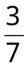 of the beads are black.

Equivalent Fractions

Example
What fraction of the flag is shaded?

6 out of 12 squares are shaded. So 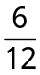of the flag is shaded.
It could also be said that 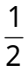the flag is shaded.
and are equivalent fractions.

Fractions 2
Outcomes
Simplifying Fractions
Equivalent fractions can be simplified as shown below:

Example 1
(a) ÷5 (b) ÷8
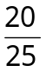 = 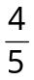 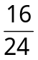 = 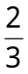
÷5 ÷8
This can be done repeatedly until the numerator and denominator are the smallest possible numbers - the fraction is then said to be in it’s simplest form.

Example 2 Simplify 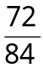 = 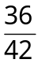 = 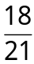 = 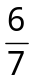 (simplest form)

Calculating Fractions of a Quantity

Example 1 Find 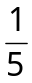 of £150
of £150 = £150 ÷ 5 = £30

Example 2 Find 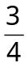 of 48
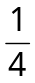 of 48 = 48 ÷ 4 = 12
so 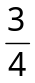 of 48 = 3 x 12 = 36

The top of a fraction is called the numerator, the bottom is called the denominator.
To simplify a fraction, divide the numerator and denominator of the fraction by the same number.

To find a unitary fraction, one with a 1 on the top, of a quantity, divide by the denominator.
To find
divide by 2, to find
divide by 3, to find
divide by 7 etc.
To find of a quantity, start by finding then multiply by 3

Percentages 1
Outcomes

36% means 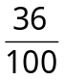 which equals 36÷100 which equals 0.36
36% = which can be simplified to 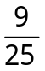

Common Percentages

Some percentages are used very frequently. It is useful to know these as fractions and decimals.
Percentage | Fraction | Decimal
1% | 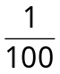 | 0.01
10% | 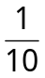 | 0.1
12.5% |  | 0.125
20% | 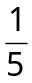 | 0.2
25% |  | 0.25
33¹/₃% | 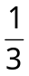 | 0.333…
50% | 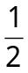 | 0.5
66²/₃% | 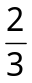 | 0.666…
75% |  | 0.75

Percent means out of 100.
A percentage can be converted to an equivalent fraction or decimal.

Percentages 2
Outcomes

Non- Calculator Methods

Method 1 Using Equivalent Fractions

Example Find 25% of £640

25% of £640 = of £640 = £640 ÷ 4 = £160

Method 2 Using 1%
In this method, first find 1% of the quantity (by dividing by 100), then multiply to give the required value.

Example Find 9% of 200g

1% of 200g = of 200g = 200g ÷ 100 = 2g

so 9% of 200g = 9 x 2g = 18g

Method 3 Using 10%
This method is similar to the one above. First find 10% (by dividing by 10), then multiply to give the required value.

Example Find 70% of £35

10% of £35 = 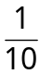 of £35 = £35 ÷ 10 = £3.50

so 70% of £35 = 7 x £3.50 = £24.50
There are many ways to calculate percentages of a quantity. Some of the common ways are shown below.

Percentages 3
Outcomes
Non- Calculator Methods (continued)

The previous 2 methods can be combined so as to calculate any percentage.

Example Find 23% of £15000

10% of £15000 = £1500 so 20% = £1500 x 2 = £3000
1% of £15000 = £150 so 3% = £150 x 3 = £450

23% of £15000 = £3000 + £450 = £3450

Finding VAT (without a calculator)

Value Added Tax (VAT) = 15%
To find VAT, firstly find 10%

Example Calculate the total price of a computer which costs £650
excluding VAT

10% of £650 = £65 (divide by 10)
5% of £650 = £32.50 (divide previous answer by 2)

so 15% of £650 = £65 + £32.50 = £97.50

Total price = £650 + £97.50 = £747.50

Percentages 4
Outcomes
Calculator Method

To find the percentage of a quantity using a calculator, change the percentage to a decimal, then multiply.

Example 1 Find 23% of £15000

23% = 0.23 so 23% of £15000 = 0.23 x £15000 = £3450
Or £15000 ÷ 100 x 23 = £3450

Example 2 House prices increased by 19% over a one year period.
What is the new value of a house which was valued at
£236000 at the start of the year?

19% = 0.19 so Increase = 0.19 x £236000 = £44840

Or Increase = £236000 ÷ 100 x 19 = £44840
Value at end of year = original value + increase
= £236000 + £44840
= £280840

The new value of the house is £280840

A more advanced method would be to calculate 119% of £236000, since a 19% increase gives 119%.
e.g. 119% of 236000 = 236000 ÷ 100 x 119 = 280840

We can also use the % button on the calculator although the mathematics department focuses on converting percentages to decimals or finding 1 % and then multiplying.
Percentages 5
Outcomes
Expressing something as a percentage

Example 1 There are 30 pupils in Class 3M. 18 are girls.
What percentage of Class 3M are girls?

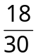 = 18 ÷ 30 = 0.6 = 60%

OR x 100% = 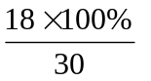= 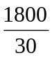 = 60%

60% of 3M are girls

Example 2 James scored 36 out of 44 his biology test. What is his
percentage mark?
Score = 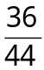 = 36 ÷ 44 = 0.81818… = 81.818..% = 82% (rounded)
See Rounding to Decimal Places

OR 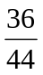 x 100% = 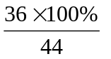= 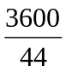 = 81.818..% = 82% (rounded)

Example 3 In class 2K, 14 pupils had brown hair, 6 pupils had blonde
hair, 3 had black hair and 2 had red hair. What
percentage of the pupils were blonde?

Total number of pupils = 14 + 6 + 3 + 2 = 25
6 out of 25 were blonde, so,
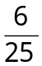 = 6 ÷ 25 = 0.24 = 24% or same as above

24% were blonde.

To find a number as a percentage of another number, first make a fraction, this can then be expressed as a percentage by finding that fraction of 100%.

Ratio 1
Outcomes

Writing Ratios
Example 1
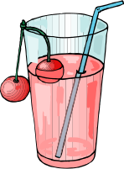

Example 2
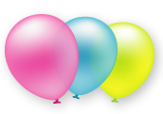 The ratio of red : blue : green is 5 : 7 : 8

Simplifying Ratios
Ratios can be simplified in much the same way as fractions.

Example 1
Purple paint can be made by mixing 10 tins of blue paint with 6 tins of red. The ratio of blue to red can be written as 10 : 6

It can also be written as 5 : 3, as it is possible to split up the tins into 2 groups, each containing 5 tins of blue and 3 tins of red.



When quantities are to be mixed together, the ratio, or proportion of each quantity is often given. The ratio can be used to calculate the amount of each quantity, or to share a total into parts.

Order is important when writing ratios.

In a bag of balloons, there are 5 red, 7 blue and 8 green balloons.

To make a fruit drink, 4 parts water is mixed with 1 part of cordial.
The ratio of water to cordial is 4:1
(said “4 to 1”)
The ratio of cordial to water is 1:4.

B B B B B R R R
B B B B B R R R
Blue : Red
= 10 : 6
= 5 : 3
To simplify a ratio, divide each figure in the ratio by the highest common factor.
Ratio 2
Outcomes
Simplifying Ratios (continued)

Example 2
Simplify each ratio:
(a) 4:6 (b) 24:36 (c) 6:3:12

(a) 4:6 (b) 24:36 (c) 6:3:12
= 2:3 = 2:3 = 2:1:4

Example 3
Concrete is made by mixing 20 kg of sand with 4 kg cement. Write
the ratio of sand : cement in its simplest form

Sand : Cement
= 20 : 4
= 5 : 1

Using ratios

The ratio of fruit to nuts in a chocolate bar is 3 : 2. If a bar contains 15g of fruit, what weight of nuts will it contain?

Fruit | Nuts
3 | 2
x5 | x5
15 | 10

So the chocolate bar will contain 10g of nuts.

Divide each figure by 2
Divide each figure by 12

Divide each figure by 3

Ratio 3
Outcomes
Sharing in a given ratio
This would be a challenging task at Third Level and more complex examples would be for pupils working at the Fourth Level.
Example

Lauren and Sean earn money by washing cars. By the end of the day they have made £90. As Lauren did more of the work, they decide to share the profits in the ratio 3:2. How much money did each receive?

Step 1 Add up the numbers to find the total number of parts

3 + 2 = 5

Step 2 Divide the total by this number to find the value of each part

90 ÷ 5 = £18

Step 3 Multiply each figure by the value of each part

3 x £18 = £54
2 x £18 = £36

Step 4 Check that the total is correct

£54 + £36 = £90 √

Lauren received £54 and Sean received £36

Proportion
Outcomes
This would be a challenging task at Third Level and more complex examples would be suitable for pupils working at the Fourth Level.

It is often useful to make a table when solving problems involving proportion.

Example 1
A car factory produces 1500 cars in 30 days. How many cars would they produce in 90 days?

Days | Cars
30 | 1500
x3 | x3
90 | 4500

The factory would produce 4500 cars in 90 days.

Example 2
5 adult tickets for the cinema cost £27.50. How much would 8 tickets cost?

Tickets | Cost
5 | £27.50
1 | £5.50
8 | £44.00

The cost of 8 tickets is £44

Two quantities are said to be in direct proportion if, when one changes, the other changes in the same way
e.g. if one quantity doubles the other also doubles.
We can use proportion to solve problems.
Find the cost of 1 ticket
Working:

£5.50 £5.50
5 £27.50 ₄x 8
£44.00
Key Words:
Mathematical Dictionary (Key words):

Add; Addition (+) | To combine 2 or more numbers to get one number (called the sum or the total)  Example: 12+76 = 88
Calculate | Find the answer to a calculation or problem. It doesn’t mean that you must use a calculator!
Denominator | The bottom number in a fraction (the number of parts into which the whole is split).
Difference (-) | The amount between two numbers (subtraction).  Example: The difference between 50 and 36 is 14  50 – 36 = 14
Division (÷) | Sharing a number into equal parts.  24 ÷ 6 = 4
Double | Multiply by 2.
Equals (=) | Makes or has the same amount as.
Equivalent fractions | Fractions which have the same value.  Example and are equivalent fractions
Estimate | To make an approximate or rough answer, often by rounding.
Evaluate | To work out the answer.
Even | A number that is divisible by 2.  Even numbers end with 0, 2, 4, 6 or 8.
Factor | A number which divides exactly into another number, leaving no remainder.  Example: The factors of 15 are 1, 3, 5, 15.
Greater than (>) | Is bigger or more than.  Example: 10 is greater than 6.  10 > 6
Least | The lowest number in a group (minimum).
Less than (<) | Is smaller or lower than.  Example: 15 is less than 21. 15 < 21.
Maximum | The largest or highest number in a group.
Minimum | The smallest or lowest number in a group.
Minus (-) | To subtract.
Most | The largest or highest number in a group (maximum).
Multiple | A number which can be divided by a particular number, leaving no remainder.  Example Some of the multiples of 4 are 8, 16, 48, 72
Multiply (x) | To combine an amount a particular number of times.  Example 6 x 4 = 24
Numerator | The top number in a fraction.
Odd Number | A number which is not divisible by 2.  Odd numbers end in 1 ,3 ,5 ,7 or 9.
Operations | The four basic operations are addition, subtraction, multiplication and division.
Order of operations | The order in which operations should be done. BOMDAS (see p9)
Place value | The value of a digit dependent on its place in the number.  Example: in the number 1573.4, the 5 has a place value  of 100.
Prime Number | A number that has exactly 2 factors (can only be divided by itself and 1). Note that 1 is not a prime number as it only has 1 factor.
Product | The answer when two numbers are multiplied together.  Example: The product of 5 and 4 is 20.
Remainder | The amount left over when dividing a number.
Share | To divide into equal groups.
Sum | The total of a group of numbers (found by adding).
Total | The sum of a group of numbers (found by adding).
Money:

Second Level | Third Level | Fourth Level
I can manage money, compare costs from different retailers, and determine what I can afford to buy.  MNU 2-09a  I understand the costs, benefits and risks of using bank cards to purchase goods or obtain cash and realise that budgeting is important.  MNU 2-09b  I can use the terms profit and loss in buying and selling activities and can make simple calculations for this.  MNU 2-09c | When considering how to spend my money, I can source, compare and contrast different contracts and services, discuss their advantages and disadvantages, and explain which offer best value to me.  MNU 3-09a  I can budget effectively, making use of technology and other methods, to manage money and plan for future expenses.  MNU 3-09b | I can discuss and illustrate the facts I need to consider when determining what I can afford, in order to manage credit and debt and lead a responsible lifestyle.  MNU 4-09a  I can source information on earnings and deductions and use it when making calculations to determine net income.  MNU 4-09b  I can research, compare and contrast a range of personal finance products and, after making calculations, explain my preferred choices.  MNU 4-09c

- Decimal places and money
- Budgeting
- Sale Prices & Offers
  - % Discounts
  - BOGOF deals
  - % extra free deals
  - 3 for the price of 2 deals
- VAT with and without a calculator
- Hire Purchase
- Loans
- Savings accounts and % Interest rates
- Interpreting bank statements
Money & Decimal Places

All calculations of money need to be written down to 2 decimal places. This could mean that we need to round numbers:

Example 1 Round £1.525 to 2 decimal places

The second number after the decimal point is a 2 - the check digit
(the third number after the decimal point) is a 5, so round up.

1.525
= 1.53 to 2 decimal places

We may also need to put in zeros to show our answers to 2 decimal places:

Example 2 Calculate the total cost of the following items
Pencil 20p
Pen 40p
Rubber 30p
Ruler 75p
Sharpener 25p

Total cost = 190p
= £1.9O to 2 decimal places

Budgeting:

Budgeting is trying to make sure our money lasts until we next receive more money.

To help us to do this we need to have an idea of how much money we will usually receive, our income, and how often we will receive it.

We then need to keep track of how much we spend, our expenditure or outgoings.

From this we can work out how much we have left, our balance. To work out the balance we need to subtract our total expenditure from our total income.

For example: Steven kept a track of his income and expenditure for a month.
Date | Details | Paid In £ | Paid out £
15 / 05 | Wages | 200.00
17 / 05 | CD’s R Us |  | 30.00
19 / 05 | Sports shop |  | 83.25
22 / 05 | Birthday Present |  | 35.00
24 / 05 | Sold old CD player on e-bay | 25.00
27 / 05 | Cinema |  | 13.50
3 / 06 | Bus travel card |  | 39.40
TOTAL: |  | 225.00 | 201.15

a) Calculate the balance:

Balance = Total income – Total expenditure
= £ 225.00 – £ 201.15
= £ 23.85

b) If Steven has a monthly income of £200.00 and typical expenditure of £128, how long will it take for Steven to save up for a new bike at a cost of £135?

Balance = £ 200 - £ 128
= £ 72

After 2 months: Balance will be £ 72 x 2 = £ 144

He will be able to afford the bike after 2 months
Sale Prices & Offers:

Percentage Discounts: Non- Calculator Methods
To find the Sale price of an item that has been discounted,
first of all we find out the value of the discount. This is
the same as finding a percentage or fraction of an amount.

Method 1 Using Equivalent Fractions

Example A Shirt usually costs £50 but is discounted by 25% in the sale. How much does it cost in the sale?

The shirt has 25% of its value taken away from its original price: 25% of £50 = of £50 = £50 ÷ 4 = £12.50
Take this away from the original price:
£ 50.00 - £12.50 = £37.50

Method 2 Using 1%
In this method, first find 1% of the quantity (by dividing by 100), then multiply to give the required value.

Example A bicycle usually costs £200 but is discounted by 20% in the sale. How much does it cost in the sale?

1% of £200 = of £ 200 = £2

so 20% of £ 200 = 20 x £ 2 = £ 40
Take this away from the original price:
£ 200 - £ 40 = £ 160

Method 3 Using 10%

This method is similar to the one above. First find 10% (by dividing by 10), then multiply to give the required value.

Example A pair of football boots are reduced by 30 % in a sale. If their original price was £70, calculate the sale price:

10% of £70 = of £70= £70÷ 10 = £7.00

30% of £70 = 3 x £7.00 = £21.00

Take this away from the original price:

£ 70 - £ 21 = £ 49

Percentage Discounts: Calculator Method
To find a percentage of a quantity using a calculator, change the percentage to a decimal, then multiply or divide by 100, to find 1%, and then multiply by the number of percent you want. .

Example 1 A car usually costs £15000 but is reduced by 23% as part of a promotion for this week only. Calculate the cost of the car now.

23% of £15000
= £15000 ÷ 100 x 23
= £3450

Take this away from the original price:

£ 15 000 - £ 3450
= £ 11 550

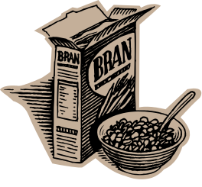
Buy One Get One Free

This offer is usually used when retailers want to clear a large number of items quickly. They are effectively reducing the price of goods by half whilst ensuring that you buy two items at a time.

This offer is only a saving if you would normally use the two items before the goods would be out of date.

If you usually buy one chocolate cake and you get one free, you haven’t made a saving you, just have an extra cake. However, if you usually buy two cakes you have made a saving.
Three for the Price of Two

This is similar to the above offer. The retailers are effectively reducing the cost to two thirds of the original price. This offer is only a saving if you would normally use the three items before the goods would be out of date.
% Extra Free

See Non-Calculator and Calculator methods for the different methods of calculating percentages.

Example 1:
A cereal packet usually contains 750g of cereal. There is a special offer packet which contains 25% extra free. How much cereal is in the special offer packet?

Calculate the number of extra grams:
25% of 750g = ¼ of 750g
½ of 750g = 375g
¼ of 750g = 187.5g

Add this to the original number of grams in the packet:
750g + 187.5g = 937.5g

Which offer is the best value?

To work this out it is useful to compare the products on a price per amount.

Look at the following special offers.

‘Swarbricks’ Brown’s Bread Wheaty Bake
600g 800g 790g
78p per loaf £1.20 98p

3 for 2 20% extra free 10% discount

a) Which offers the best value for money per gram of bread without the special offer?

Swarbricks: 78p ÷ 600g
= 0.13p per gram

Brown’s Bread 120p ÷ 800g
= 0.15p per gram

Wheaty Bake 98p ÷ 790g
= 0.12p per gram

Wheaty Bake is the best value for money at 0.12p per gram

b) Which offers the best value for money per gram of bread with the special offer?

Swarbricks: 3 for the price of 2
Cost = 2 x 78
= 156p

Grams = 3 x 600g
= 1800g

Cost per gram = 156p ÷ 1800g
= 0.09p per gram

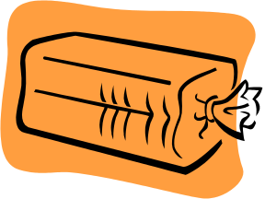
Brown’s Bread 20% extra free
Cost = 120p
Grams = 800g + (20% of 800g)
= 800g + 160g
= 960g

Cost per gram = 120p ÷ 960g
= 0.13p per gram

Brown’s Bread: 0% extra free
Cost = 98p – (10% of 98p)
= 98p – 9.8p
= 88.2p
Grams = 790g

Cost per gram = 88p ÷ 790g
= 0.11p per gram

The Swarbrick’s special offer is the best value for money if you would normally use 3 loaves of bread before the bread went stale.
Finding VAT (without a calculator)

Value Added Tax (VAT) = 15% or 17.5% when rates increase again next year
To find VAT, firstly find 10%

Example Calculate the total price of a computer which costs £650
excluding VAT

10% of £650 = £65 (divide by 10)
5% of £650 = £32.50 (divide previous answer by 2)
2.5% of £650 = £16.25 (divide previous answer by 2)

so 15% of £650 = £65 + £32.50 = £97.50
17.5% of £650 = £65 + £32.50 + £16.25 = £113.75

Total price (+ 15 % VAT) = £650 + £97.50 = £747.50
Total price (+ 17.5 % VAT) = £650 + £113.75 = £763.75
Finding VAT (with a calculator)

Value Added Tax (VAT) = 15%
17.5% when rates increase again next year

Example Calculate the total price of a computer which costs £650
excluding VAT

15% = 0.15
0.15 x £650 = £97.50 or £650 ÷ 100 x 15 = £97.50
Total price (+ 15 % VAT) = £650 + £97.50 = £747.50

17.5% = 0.175
0.175 x £650 = £113.75 or £650 ÷ 100 x 17.5 = £113.75
Total price (+ 17.5 % VAT) = £650 + £113.75 = £763.75
What is Hire Purchase?
Hire purchase
A contract to hire goods for a specified period and at a fixed cost. If you pay all the installments over the agreed period, the goods become your property. However, you may return the goods during the specified period, and not be held responsible for paying any future installments. If you fail to make all the repayments the goods will be taken from you.
Calculating the cost of a Hire Purchase Agreement
With hire purchase often, a deposit needs to be made. This must be paid before the goods can be taken home,
Often this deposit is a percentage of the cash price .

For Example:
A three piece suite has a Cash price of £1200
Alternatively it can be bought with a 10% deposit and 12 monthly instalments of £99.99
What is the Total cost of the three piece suite with the HP agreement?
10% of £1200 = £120
12 x £99.99 = £1199.88
£1199.88 + £120 = £1319.88

This agreement costs £119 extra but the customer doesn’t need to pay the full price all at once
Loan Agreements
A Loan is a sum of money which is lent out on the proviso that the full amount, plus interest is paid back over a period of time. This is different to an HP agreement in that the item you have bought becomes your property straight away. This is because the total price of the item has been paid out on your behalf by a bank or other money lender.

For example, the same three piece suite can be bought with a £1200 Loan.
The bank loaning you the money, say that you must pay the money back as:
6 Repayments of £215
How much more does the loan cost than paying cash?
We can work this out by finding the total repayments, and you do this by multiplying 6 by £215.
total repayments = 6 x £215 = £ 1290

The loan costs £90 more than paying in cash
.
Savings Accounts and Interest Rates
If you save money in a bank account, the bank will pay you interest. You are, in effect, lending the bank money which they will invest so that the bank can earn more money. They pay you some of this money back as interest.

The amount of interest they will pay is shown as a percentage. The bank will pay you this percentage of the money you have paid in per year. This figure is usually called an APR or Annual Percentage Rate. More recently banks may state the AER or Annual Equivalent Rate. This rate takes into account how often the bank pays interest.

For Example:
A bank account has an APR of 5% paid once a year. You invest £1000 pounds. How much money will you have at the end of the year?
Interest = 5% of £1000 = £1000 ÷100 x 5
Interest = £50
Balance at the end of the year = £1050
The AER is 5%

Another bank account with an APR of 5% will pay 2.5% interest every 6 months. How much money will you have at the end of the year?
After 6 months:
Interest = 2.5% of £1000 = £1000 ÷100 x 2.5
Interest = £25
Balance at the end of 6 months = £1025

After a further 6 months:
Interest = 2.5% of £1025 = £1025 ÷100 x 2.5
Interest = £25.63
Balance at the end of a year = £1025 + £25.63
= £1050.63
The AER is 5.06%

The higher the APR or AER, the more interest you will earn. Some banks restrict how often you can take your money out of the savings account, especially if the interest rate is high. You should take this into account when deciding which savings account to open.
Understanding Bank Statements

NE Bank Ltd
Statement of account no. 0123456789

Sheet 1 Sort Code: 12-34-56

Date | Type | Details | Paid In  £ | Paid Out  £ | Balance  £
15 May | CHQ | Wages | 200.00 |  | 200.00
17 May | DEB | CD’s R Us |  | 30.00 | 170.00
19 May | DEB | Sports Bargain Centre |  | 83.25 | 86.75
22 May | CPT | Cash Point |  | 35.00 | 51.75
24 May | CHQ | Cheque no. 123 | 25.00 |  | 76.75
27 May | DEB | Big Screen Cinemas |  | 13.50 | 63.25
3 Jun | DEB | Transport Executive |  | 39.40 | 23.85

A bank statement keeps track of the balance (how much money is left in the bank account) after every payment or transaction. This is shown in the end column.

Every transaction has the date recorded

Banks have codes to show what type of payment has been made.
E.g. CHQ means a cheque
DEB means a debit card
CPT means a withdrawal from a cash point machine

The details can show the name of the company or people money has been paid out to or in from. This can also includes cheque numbers and the location of cash machines.

Key Words:
Mathematical Dictionary (Key words):

Estimate | To make an approximate or rough answer, often by rounding.
Discount | The amount of money that the price of an item has been reduced by , the amount taken off the original price.
Regular Price | The original price that an item has been advertised for before a special offer or discount has been.
Sale Price | The new price an item costs after a discount or special offer.
Percentage off | The percentage of the original price that has been taken off.
Bargain | An item that has been bought at a reduced price which the customer believes to be a good deal.
Deals | Another term for a special offer.

Time:

Second Level | Third Level | Fourth Level
I can use and interpret electronic and paper-based timetables and schedules to plan events and activities, and make time calculations as part of my planning.  MNU 2-10a  I can carry out practical tasks and investigations involving timed events and can explain which unit of time would be most appropriate to use.  MNU 2-10b  Using simple time periods, I can give a good estimate of how long a journey should take, based on my knowledge of the link between time, speed and distance.  MNU 2-10c | Using simple time periods, I can work out how long a journey will take, the speed traveled at or distance covered, using my knowledge of the link between time, speed and distance.  MNU 3-10a | I can research, compare and contrast aspects of time and time management as they impact on me.  MNU 4-10a  I can use the link between time, speed and distance to carry out related calculations.  MNU 4-10b

Time notation
Time Periods
Distance, Speed & Time
Interpreting Timetables
Time, Decimals & Graphs
Time Notation

12-hour clock
Time can be displayed on a clock face, or digital clock.
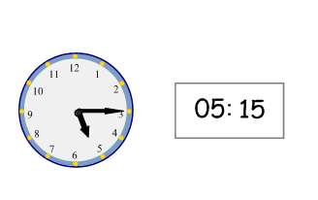
When writing times in 12 hour clock, we need to add a.m. or p.m. after the time.
a.m. is used for times between midnight and 12 noon (morning)
p.m. is used for times between 12 noon and midnight (afternoon / evening).

24-hour clock
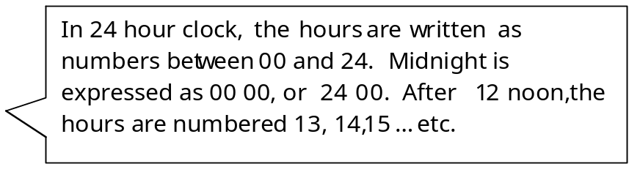
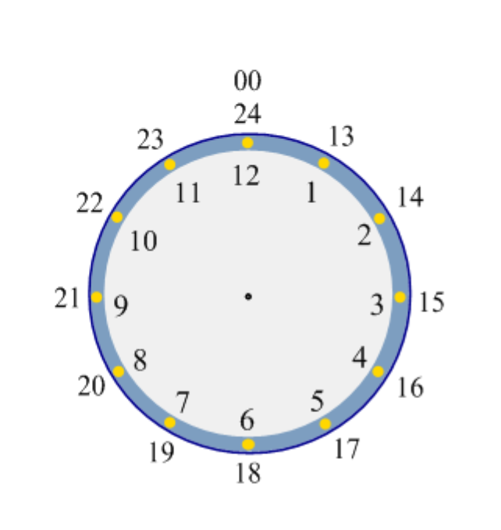

Time may be expressed in 12 or 24 hour notation.

Examples

9.55 am 09 55 hours
3.35 pm 15 35 hours
12.20 am 00 20 hours
02 16 hours 2.16 am
20 45 hours 8.45 pm
These clocks both show fifteen minutes past five, or quarter past five.

Time Periods
It is essential to know the number of months, weeks and days in a year, and the number of days in each month.

Time Facts
In 1 year, there are: 365 days (366 in a leap year)
52 weeks
12 months

The number of days in each month can be remembered using the rhyme: “30 days hath September,
April, June and November,
All the rest have 31,
Except February alone,
Which has 28 days clear,
And 29 in each leap year.”

Distance, Speed and Time.
For any given journey, the distance travelled depends on the speed and the time taken. The relationship between each of these is shown by the following formula:
Distance = Speed x Time or D = S T

Speed = 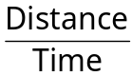 or S = 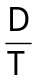

Time = 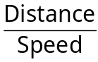 or T = 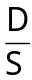

Example 1
Carl travels 70 km in 2 hours. What is his average speed?
Speed = | distance  time

Speed = | 70  2 | = 35 km/h
Remember: We were given the distance in km and the time in h, so the units for speed are km/h.

Interpreting Timetables

Destination | Time | Time | Time | Time | Time | Time | Time | Time
Stornoway Bus Stn. | 0755 | 1030 | 1300 | 1430 | 1540 | 1715 | 1800 | 1930
W I Hospital | 0800 | 1035 | 1305 | 1435 | 1550 | 1720 | 1805 | 1935
Barvas Junction | 0815 | 1050 | 1320 | 1450 | 1605 | 1735 | 1820 | 1950
Upper Barvas | 0817 | 1052 | 1322 | 1452 | 1607 | 1737 | 1822 | 1952
Ballantrushal | 0820 | 1055 | 1325 | 1455 | 1610 | 1740 | 1825 | 1954
Airidhantuim School | 0822 | 1057 | 1327 | 1457 | 1612 | 1742 | 1827 | 1955
Borve Church | 0826 | 1102 | 1332 | 1502 | 1617 | 1747 | 1832 | 2002
Melbost Borve | 0828 | 1104 | 1334 | 1504 | 1619 | 1749 | 1834 | 2004
South Galson | 0833 | 1107 | 1337 | 1507 | 1622 | 1752 | 1837 | 2007

Examples of Questions:

- I want to go to the youth club at Borve Church which starts at 6pm. What time must I catch the bus at Stornoway Bus Station?

6pm is shown as 1800 h on the timetable
The most suitable bus arrives at Borve Church at 1747
This leaves Stornoway at 1715 h

- The 0755 bus from Stornoway is running 6 minutes late. What time does it reach South Galson?

Add 6 minutes to the arrival time at Galson
This is 0833 h. It arrives at 0839 h

- How long does the first bus journey from W I Hospital to Melbost Borve take?

The bus leaves WI Hospital at 0800 h and arrives at Melbost Borve at 0828 h.
The journey time is 28 minutes.
Time, Decimals and Graphs

Pupils can find expressing times as fractions and decimal fractions confusing, leading to errors. This can also cause problems when pupils draw graph scales involving time intervals.

e.g. a pupil may label the axis of a graph as shown.
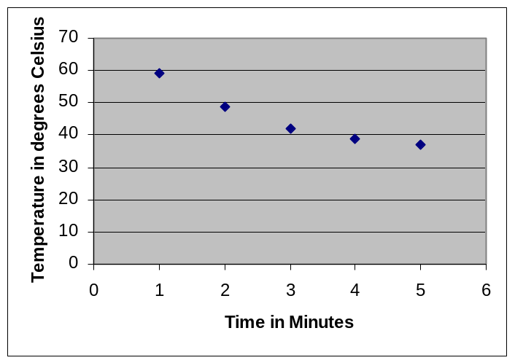

Pupils sometimes make the error that 50 seconds is equivalent to 0.5 minutes. To avoid this error, pupils should convert minutes into seconds for graph work.
Key Words:
Mathematical Dictionary (Key words):

a.m. | (ante meridiem) Any time in the morning (between midnight and 12 noon). am = After midnight
p.m. | (post meridiem) Any time in the afternoon or evening (between 12 noon and midnight). pm = past midday
timetable | A table showing the times that someone or something is planned to arrive and depart.
Measurement

Second Level | Third Level | Fourth Level
I can use my knowledge of the sizes of familiar objects or places to assist me when making an estimate of measure.  MNU 2-11a  I can use the common units of measure, convert between related units of the metric system and carry out calculations when solving problems.  MNU 2-11b  I can explain how different methods can be used to find the perimeter and area of a simple 2D shape or volume of a simple 3D object.  MNU 2-11c | I can solve practical problems by applying my knowledge of measure, choosing the appropriate units and degree of accuracy for the task and using a formula to calculate area or volume when required.  MNU 3-11a | I can apply my knowledge and understanding of measure to everyday problems and tasks and appreciate the practical importance of accuracy when making calculations.  MNU 4-11a

Reading Scales
Conversions between units
Metric
Imperial
Conversion Graphs
Conversion between units of area and volume
Perimeter
Area
Rectangle
Triangle
Compound Shapes
Parallelogram
Volume
Cuboids
Other Prisms
Reading scales

Scale 1

5 6

In this scale the difference between 5 and 6 is 1, and the space has been divided into 4, so each division represents 1 ÷ 4 = 0.25.

The arrow is pointing to 5 + 0.25 + 0.25 + 0.25 = 5.75

Scale 2 - a speedometer
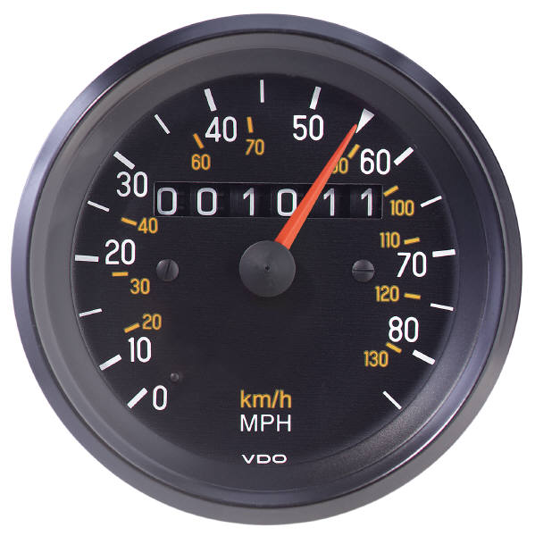
The difference between 50 and 60 is 10 and the space has been divided into 2, so each division represents 10 ÷ 2 = 5.
The arrow is pointing to 50 + 5 = 55

Converting between units

The table shows some of the most common equivalences between different units of measure. Make sure you know these conversions.

Length | Weight | Capacity
 | 1 tonne = 1000kg
1 km = 1000m | 1kg = 1000g
1m = 100cm = 1000mm | 1g = 1000mg | 1l = 100cl = 1000ml
1cm = 10mm |  | 1cl = 10ml

If converting from a larger unit (eg m) to a smaller unit (eg cm), check what number of smaller units are needed to make 1 larger unit, then multiply that number with the relevant number of the larger units.
If converting from a smaller unit (eg cm) to a larger unit (eg m), check what number of smaller units are needed to make 1 larger unit, then divide that number into the relevant number of the larger units.
Remember: To convert from a larger unit to a smaller one, multiply.
To convert from a smaller unit to a larger one, divide.

Worked example
We know that 1m = 100cm
So, to convert from m to cm we multiply by 100, and to convert from cm to m we divide by 100.
Eg: 3.2m = 320cm (3.2 x 100 = 320)
400cm = 4m (400 ÷ 100 = 4)

Metric and imperial units
Imperial measures are old-fashioned units of measure. These days we have mostly replaced them with metric units, but despite our efforts to 'turn metric', we still use many imperial units in our everyday lives. It is therefore important that we are able to calculate rough equivalents between metric and imperial units.
Here are some conversions that you will need to know:

1 inch is about 2.5cm
1 foot is about 30cm
1 gallon is about 4.5 litres
--------
1kg is about 2.2 pounds
1 litre is about 1.75 pints
8km is about 5 miles
(1km is about 5/8 mile, and 1 mile is about 8/5km)
Worked example
We know that 1 litre is about 1.75 pints.
To convert from litres to pints, we multiply by 1.75.
To convert from pints to litres, we divide by 1.75.
E.g. 2 litres = 3.5 pints (2 x 1.75 = 3.5)
7 pints = 4 litres (7 ÷ 1.75 = 4)

Conversion graphs
Another way of converting units is to use a conversion graph.
The following example shows a graph that enables us to convert between kilometres and miles:
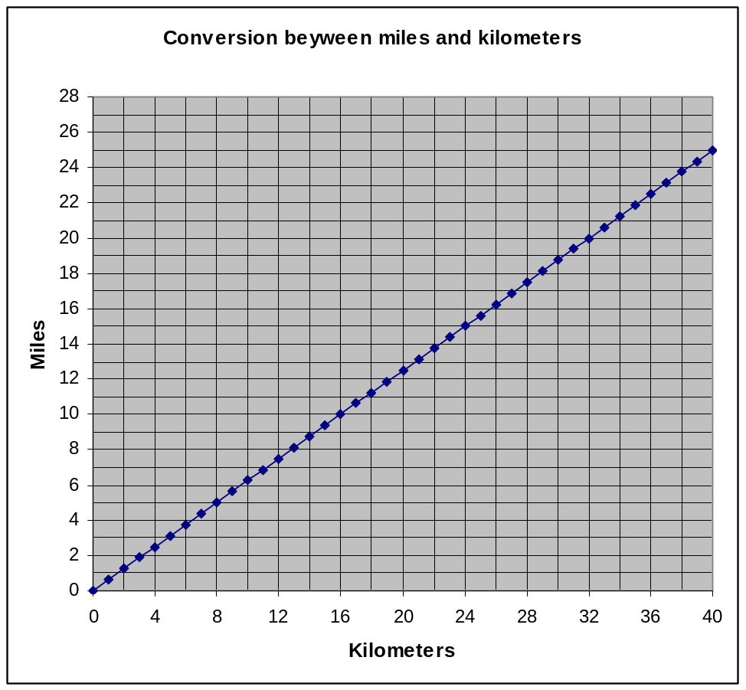
The line on the graph shows that 12km is equivalent to 7.5 miles.

Example:
Use the graph to convert:
a) 20km to miles.

20km is about 12.5 miles.
b) 20 miles to km.

20 miles is about 32km

Converting between area and volume
When you are converting one sort of unit to another, you need to know what number of the smaller units are needed to make 1 larger unit (eg 1000m = 1km), then:

- If converting from a larger unit (eg m) to a smaller unit (eg cm), you multiply.
- If converting from a smaller unit (eg cm) to a larger unit (eg mm), you divide.
For Example:
Convert 50 000 cm² into m².
Solution
We know that 1m = 100cm.
1 m
100 cm
=
100cm
1 m

So, 1m2 = 100cm x 100cm = 10 000cm².
We are converting from a smaller unit (cm²) to a larger unit (m²), so we divide.
50 000 cm² = 50 000 ÷ 10 000 = 5m².

Perimeter

The perimeter of a shape is the length of its boundary.
Think of an ant starting from one corner of a small box, and walking all the way round the edge - what distance will it have walked?

Example question
A plan of a play area is shown below:
8 m
5 m
15 m
x
y

20 m

a) Calculate the length of x and y
The length of the play area is 20m, so x = 20 - 8 =12m.The width of the play area is 15m, so y = 15 - 5 = 10m.
b) Calculate the perimeter of the play area.
Perimeter = 20 + 15 +8 + 5 + 12 + 10
= 70 m

Area of a rectangle
l
b
Area = l x b
The area of a rectangle is its length multiplied by its breadth.

The formula is: area = length x breadth

Look at the triangle below:
If you multiplied the base by the perpendicular height, you would obtain the area of a rectangle. The area of the triangle is half the area of the rectangle.
So to find the area of a triangle, we multiply the base by the perpendicular height and divide by two. The formula is:
h
b

Area =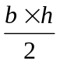 or Area = 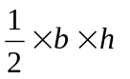
Area of a triangle

Area of compound shapes

For example
To cover the floor of a doll’s house, a carpet is needed with the following shape. Find the area of carpet needed to cover this shape:
4 cm
4 cm

4 cm
8 cm
4 cm

4 cm
4 cm
4 cm
8 cm
4 cm
4 x 12 = 48 cm²
4 x 4 =
16cm²
4 x 4 =
16cm²
Method 1
We can divide the shape into squares and rectangles, find their individual areas and then add them together.

Area = 16 + 16 + 48 = 80cm²

4 cm
4 cm
8 cm
4 x 4 =
16cm²
Method 2
We can imagine the shape as a large rectangle with a section cut out!
We find the area of the large rectangle (12 x 8) and then subtract the part that has been cut out (4 x 4)

12 cm

Area = (12 x 8) - (4 x 4) = 96 - 16 = 80cm²

Area of a parallelogram
The area of a parallelogram is b x h (base x perpendicular height).
We can see that this is true by rearranging the parallelogram to make a rectangle!

height
base
Remember: We are using the perpendicular height of the parallelogram, not the sloping height.

For Example:
Find the area of this parallelogram:

4 cm
3 cm
Not to scale

7 cm

We now know how to find the area of a parallelogram, but what happens if we need to find the base or the height? Easy - we just rearrange the formula!
A = b x h

h = A
b
b = A
h

For example

h

4 cm
The area of this parallelogram is 12cm2, what is its perpendicular height?
Answer
The perpendicular height is 12 ÷ 4 = 3cm.

Volume of Solid Shapes

l
h
b

To find the volume of a cuboid we multiply
its length by its breadth by its height.
Volume = l x b x h

For example:
The volume of this cereal packet is 8 x 20 x 30 = 4800cm³


20 cm
8 cm
30 cm

Volume of a prism
l
h
b
We already know that the volume of a cuboid is l x b x h.
The area of the shaded end of the cuboid (the cross section) is b x h, so we can also say that the volume of a cuboid is:
Volume = Area of cross section x length

This formula works for all prisms:
length
Volume of a cylinder = area of circle x length

Volume of triangular = area of triangle x length
prism
length

Volume of 'L'-shaped prism = area of 'L'-shape x length

length

2 cm
5 cm
4 cm

Example 1
What is the volume of this triangular prism?

Answer
Volume
= area of triangle x length
= 1/2 x 2 x 5 x 4
= 20cm³

Example 2
What is the volume of this prism?
1 cm
8 cm
2 cm
2 cm
1 cm
3 cm
3 cm

Answer
Volume = area of L-shape x length

Using the measurements in purple we can work out the measurements in red:
= (3 x 1) + (2 x 1) x length
= 5 x 8

= 40 cm³
Key Words:
Mathematical Dictionary (Key words):

Area | Amount of surface
Perimeter | Distance around the outside edge
Volume | Amount of space inside a shape or the amount of space an object takes up
Sphere
Prism | 3-dimensional shape with the same cross section along its length
Triangular Prism | 3-dimensional shape with a triangular cross section along its length
Cylinder | Circular prism – see triangular prism
Cuboid | Rectangular prism - see triangular prism
Information handling

Data and analysis

Second Level | Third Level | Fourth Level
Having discussed the variety of ways and range of media used to present data, I can interpret and draw conclusions from the information displayed, recognising that the presentation may be misleading.  MNU 2-20a  I have carried out investigations and surveys, devising and using a variety of methods to gather information and have worked with others to collate, organise and communicate the results in an appropriate way.  MNU 2-20b | I can work collaboratively, making appropriate use of technology, to source information presented in a range of ways, interpret what it conveys and discuss whether I believe the information to be robust, vague or misleading.  MNU 3-20a | I can evaluate and interpret raw and graphical data using a variety of methods, comment on relationships I observe within the data and communicate my findings to others.  MNU 4-20a
Tables
Bar Graphs
Line Graphs
Scatter Graphs
Pie Charts
Averages
Stem & Leaf Diagrams

Literacy? Press / bias
Conclusions in science
Tables
Outcomes

Example 1 The table below shows the average maximum
temperatures (in degrees Celsius) in Barcelona and Edinburgh.

 | J | F | M | A | M | J | J | A | S | O | N | D
Barcelona | 13 | 14 | 15 | 17 | 20 | 24 | 27 | 27 | 25 | 21 | 16 | 14
Edinburgh | 6 | 6 | 8 | 11 | 14 | 17 | 18 | 18 | 16 | 13 | 8 | 6

The average temperature in June in Barcelona is 24°C

Frequency Tables are used to present information. Often data is grouped in intervals.

Example 2 Homework marks for Class 4B

27 30 23 24 22 35 24 33 38 43 18 29 28 28 27
33 36 30 43 50 30 25 26 37 35 20 22 24 31 48

Mark | Tally | Frequency
16 - 20 | || | 2
21 - 25 | |||| || | 7
26 - 30 | |||| |||| | 9
31 - 35 | |||| | 5
36 - 40 | ||| | 3
41 - 45 | || | 2
46 - 50 | || | 2

Each mark is recorded in the table by a tally mark.
Tally marks are grouped in 5’s to make them easier to read and
count.

It is sometimes useful to display information in graphs, charts or tables.

Information Handling : Bar Graphs
Outcomes
Bar graphs are often used to display data. The horizontal axis should show the categories or class intervals, and the vertical axis the frequency. All graphs should have a title, and each axis must be labelled.

Example 1 The graph below shows the homework marks for Class 4B. 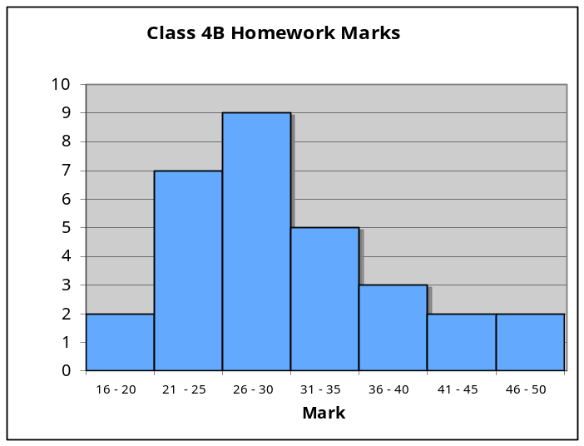

Example 2 How do pupils travel to school?
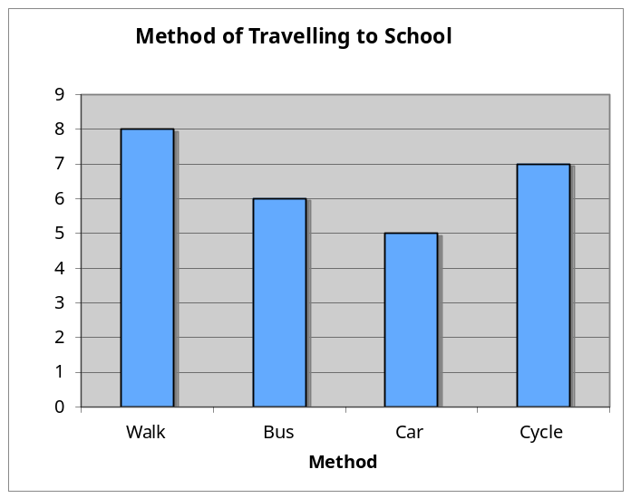
When the horizontal axis shows categories, rather than grouped intervals, it is common practice to leave gaps between the bars.

Number of Pupils

Number of Pupils
Information Handling : Line Graphs
Outcomes
Line graphs consist of a series of points which are plotted, then joined by a line. All graphs should have a title, and each axis must be labelled. The trend of a graph is a general description of it.

Example 1 The graph below shows Heather’s weight over 14 weeks as she follows an exercise programme.
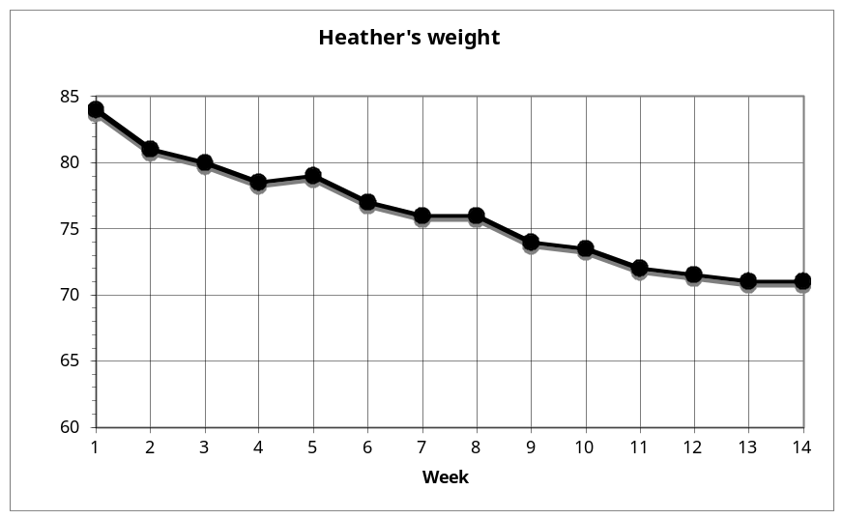
The trend of the graph is that her weight is decreasing.

Example 2 Graph of temperatures in Edinburgh and Barcelona.
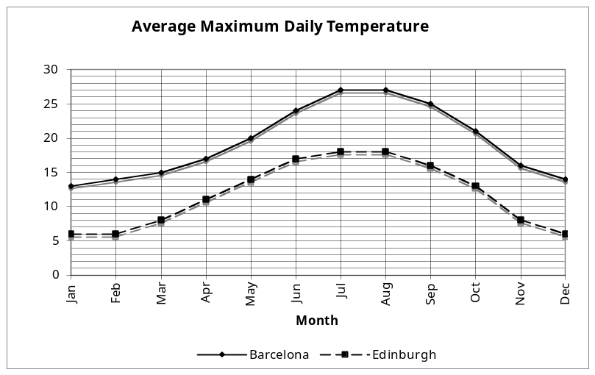

kg
⁰C
Information Handling : Scatter Graphs
Outcomes

Example The table below shows the height and arm span of a group
of first year boys. This is then plotted as a series of points on the graph below.
Arm Span (cm) | 150 | 157 | 155 | 142 | 153 | 143 | 140 | 145 | 144 | 150 | 148 | 160 | 150 | 156 | 136
Height (cm) | 153 | 155 | 157 | 145 | 152 | 141 | 138 | 145 | 148 | 151 | 145 | 165 | 152 | 154 | 137
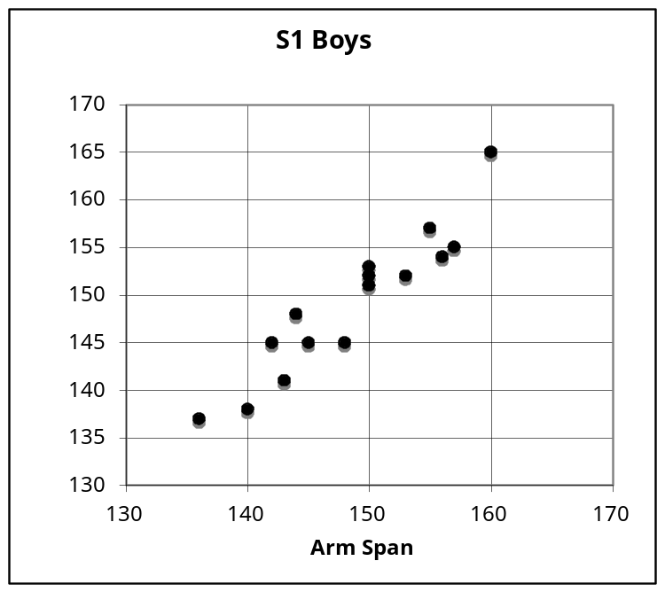
The graph shows a general trend, that as the arm span increases, so does the height. This graph shows a positive correlation.

The line drawn is called the line of best fit. This line can be used to provide estimates. For example, a boy of arm span 150cm would be expected to have a height of around 151cm.

Note that in some subjects, it is a requirement that the axes start from zero.
A scatter diagram is used to display the relationship between two variables.
A pattern may appear on the graph. This is called a correlation.

Height
cm
cm
Information Handling : Pie Charts
Outcomes

Example 30 pupils were asked the colour of their eyes. The
results are shown in the pie chart below.
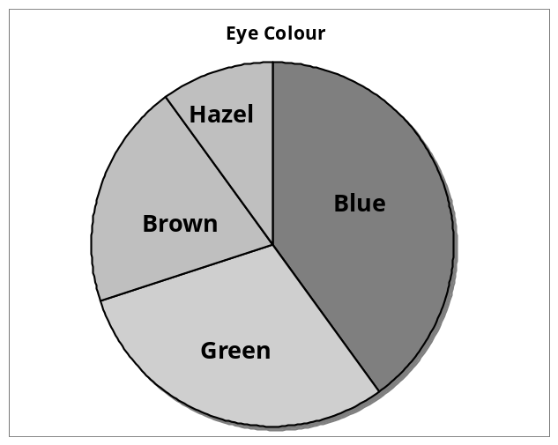
How many pupils had brown eyes?

The pie chart is divided up into ten parts, so pupils with
brown eyes represent 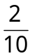 of the total.
of 30 = 6 so 6 pupils had brown eyes.

If no divisions are marked, we can work out the fraction by measuring the angle of each sector.

The angle in the brown sector is 72°.
so the number of pupils with brown eyes
= 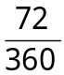 x 30 = 6 pupils.
If finding all of the values, you can check your answers - the total should be 30 pupils.

A pie chart can be used to display information. Each sector (slice) of the chart represents a different category. The size of each category can be worked out as a fraction of the total using the number of divisions or by measuring angles.

Information Handling : Pie Charts 2
Outcomes
Drawing Pie Charts
Example: In a survey about television programmes, a group of people were asked what was their favourite soap. Their answers are given in the table below. Draw a pie chart to illustrate the information.

Soap | Number of people
Eastenders | 28
Coronation Street | 24
Emmerdale | 10
Hollyoaks | 12
None | 6

Total number of people = 80

Eastenders = 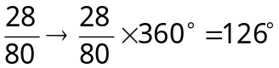
Coronation Street = 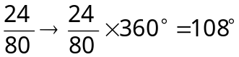
Emmerdale = 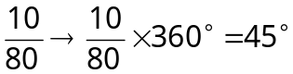
Hollyoaks =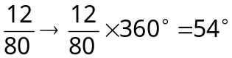
None =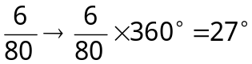
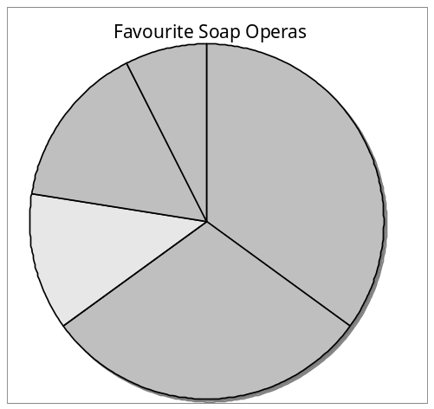

On a pie chart, the size of the angle for each sector is calculated as a fraction of 360°.

Statistics

Check that the total = 360°

Eastenders
Coronation
Street
Emmerdale
Hollyoaks
None
Information Handling : Averages
Outcomes

Mean
The mean is found by adding all the data together and dividing by the number of values.
Median
The median is the middle value when all the data is written in numerical order (if there are two middle values, the median is half-way between these values).
Mode
The mode is the value that occurs most often.

Range
The range of a set of data is a measure of spread.
Range = Highest value – Lowest value

Example Class 1A4 scored the following marks for their homework assignment. Find the mean, median, mode and range of the results.

7, 9, 7, 5, 6, 7, 10, 9, 8, 4, 8, 5, 7, 10

Mean = 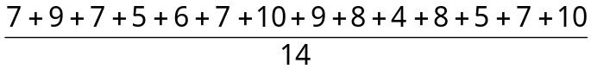
= 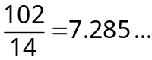 Mean = 7.3 to 1 decimal place

Ordered values: 4, 5, 5, 6, 7, 7, 7, 7, 8, 8, 9, 9, 10, 10
Median = 7

7 is the most frequent mark, so Mode = 7

Range = 10 – 4 = 6
To provide information about a set of data, the average value may be given. There are 3 different types of average value – the mean, the median and the mode.

Stem and leaf diagrams
A Maths test is marked out of 50.
The marks for the class are shown below:

7 | 36 | 41 | 39 | 27 | 21
24 | 17 | 24 | 31 | 17 | 13
31 | 19 | 8 | 10 | 14 | 45
49 | 50 | 45 | 32 | 25 | 17
46 | 50 | 23 | 18 | 12 | 6

We have all the information we need, but it is very hard to interpret!
For example, is it easy to tell whether more children got marks in the 20s than the 30s?
Can you tell at a glance what the highest mark was, or whether more than one person achieved the same result? - Probably not!
One way to overcome this is to represent the data in a more appropriate way. Here we are going to use a stem and leaf diagram.
This is an example of a stem and leaf diagram. It shows exactly the same results as in the example above:
The key shows us how to read the diagram
6 is recorded as 06

012345
KEY: 2 5 means 25

6 7 8
0 2 3 4 7 7 7 8 9
1 3 4 4 5 7
1 1 2 6 6 9
1 5 5 6 9
0 0

This number is 49

The stem and leaf diagram is formed by splitting the numbers into two parts - in this case tens and units.
The tens form the 'stem' and the units form the 'leaves'.
This information is given to us in the Key.
It is usual for the numbers to be ordered, so - for example - the row shows the numbers 21, 23, 24, 24, 25, and 27 in order.
2 | 3 4 4 5 7

012345
KEY: 2 | 5 means 25

Example 1
6 7 8
0 2 3 4 7 7 7 8 9
1 3 4 4 5 7
1 1 2 6 6 9
1 5 5 6 9
0 0
a) How many children scored 36?

The answer is two children
(see right)

b) What was the most common score?
012345
6 7 8
0 2 3 4 7 7 7 8 9
1 3 4 4 5 7
1 1 2 6 6 9
1 5 5 6 9
0 0
KEY: 2 | 5 means 25
The answer is 17 marks
(see right)
Key Words:
Mathematical Dictionary (Key words):

Average | Mean, Median and Mode
Data | A collection of information (may include facts, numbers or measurements).
Frequency | How often something happens. In a set of data, the number of times a number or category occurs.
Line Graph
Mean | The arithmetic average of a set of numbers (see p32)
Median | Another type of average - the middle number of an ordered set of data (see p32)
Mode | Another type of average – the most frequent number or category (see p32)
Pie Chart | Different ways of presenting data in the form of a graph or chart.
Scatter Graph
Stem & Leaf Diagram
Table
Bar Graph
Ideas of chance and uncertainty

Second Level | Third Level | Fourth Level
I can conduct simple experiments involving chance and communicate my predictions and findings using the vocabulary of probability.  MNU 2-22a | I can find the probability of a simple event happening and explain why the consequences of the event, as well as its probability, should be considered when making choices.  MNU 3-22a | By applying my understanding of probability, I can determine how many times I expect an event to occur, and use this information to make predictions, risk assessment, informed choices and decisions.  MNU 4-22a

Describing Probabilities
Finding Probabilities
Experimental Probabilities
Sum of Probabilities
Combined Events

Describing probabilities
We often make judgments as to whether an event will take place, and use words to describe how probable that event is.
For example, we might say that it is likely to be sunny tomorrow, or that it is impossible to find somebody who is more than 3m tall.

The probability scale
In mathematics we use numbers to describe probabilities. Probabilities can be written as fractions, decimals or percentages. We can also use a probability scale, starting at 0 (impossible) and ending at 1 (certain).

Christmas day will be on the 25th December this year

It will rain in the first week in December

You toss a coin and get ‘tails’

You buy a lottery ticket and win the jackpot

You grow another nose
1 (certain)

½ (even chance)

0 (impossible)

Finding probabilities
When we throw a die (plural: dice), there are six possible different outcomes. It can show either 1, 2, 3, 4, 5 or 6.
But how many possible ways are there of obtaining an even number? Clearly, there are three: 2, 4 and 6.
We say that the probability of obtaining an even number is 3/6
(= 1/2 or 0.5 or 50%)

The probability of an outcome = | number of ways the outcome can happen  total number of possible outcomes
Example 1
How many outcomes are there for the following experiments?
List all the possible outcomes.
a) Tossing a coin.

There are two possible outcomes (head and tail).

b) Choosing a sweet from a bag containing 1 red, 1 blue, 1 white and 1 black sweet.

There are four possible outcomes (red, blue, white and black).

c) Choosing a day of the week at random.

There are seven possible outcomes (Sunday, Monday, Tuesday, Wednesday, Thursday, Friday and Saturday).
Example 2
Sally writes the letters of the word 'MATHEMATICS' on separate cards and places them in a bag. She then draws a card at random.
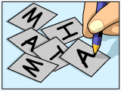
What is the probability that Sally chooses the letter 'A'?
There are 11 letters in MATHEMATICS, 2 of which are A, so the probability that Sally chooses the letter A is 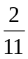
Experimental probability

What is wrong with the following statement?

"The probability of obtaining a 6 when I throw a die is ¹/₆ - so if I throw the die 6 times I should get exactly one 6."
In theory this statement is true, but in practice it is unlikely to be the case. Try throwing a die 6 times - you won't always get a six.
Have a go at this:

Example 1:
Kate and Josh each throw a die 30 times.
a) How many times would you expect Kate to obtain a 6?

In theory, Kate should obtain a 6 on 1/6 of her throws.1/6 of 30 is 5.
Therefore, we would expect her to obtain a 6 on 5 of her 30 throws.

In theory, Kate should obtain a 6 on 1/6 of her throws. Therefore, we would expect her to obtain a 6 on 5 of her throws.
b) How many times would you expect Josh to obtain a 6?

We would also expect Josh to obtain a 6 on 5 of his 30 throws.

If an experiment is repeated, the results are not necessarily the same each time.
However, it is more likely that their combined results were closer to the expected outcome (10 x 6s) than their individual results.
In other words, if you do a large number of trials you will get a more accurate result.

Sum of probabilities

If we toss a coin, the probability of obtaining a head is 1/2 and the probability of obtaining a tail is also 1/2.

P(head) + P(tail) = ¹/₂ + ¹/₂ = 1
If we choose a letter at random from the word 'SUMS', the probability of obtaining the letter 'S' is 2/4, the probability of obtaining the letter 'U' is 1/4 and the probability of obtaining the letter 'M' is 1/4.
P(S) + P(U) + P(M) = ²/₄ + ¹/₄+ ¹/₄ = 1
We can say that:
'the sum of the probabilities of all possible outcomes is 1'

Example 1
The probability that I am late for work tomorrow is 2/9. What is the probability that I am not late for work?
Remember that there are two possible outcomes - being late and not being late. The sum of their probabilities must add up to 1, so the probability of not being late is 1 - 2/9 = 7/9

Combined events
We have seen that probability of an outcome is
number of ways an outcome can happen
total number of possible outcomes
However, finding the total number of possible outcomes is not always straightforward - especially when we have more than one event.

Example 1
Two coins are tossed, once each. What is the total number of possible outcomes when they land, with either their heads or their tails uppermost?
Solution
The total number of possible outcomes is not three (two heads, a head and a tail or two tails). To find the true number of possible outcomes, we must list the results or use a table.

1. Using a list
1st coin | 2nd coin
H | H
H | T
T | H
T | T

2. Using a table
 |  | 1st coin
 |  | H | T
2nd coin | H | (H, H) | (H, T)
2nd coin | T | (T, H) | (T, T)

From both these methods we can see that there are four possible outcomes. We can use this fact to calculate probabilities.
Eg: there is only one way of obtaining two heads, so the probability (P) of obtaining 2 heads is 1/4 .
We can say P (two heads) = 1/4
There are two ways of obtaining a head and a tail, so P (head and tail) = 2/4 = 1/2
When listing possible outcomes, try to be as logical as possible. If you repeat or forget any of them, it will affect the rest of your answers.

Example question:
Two tetrahedral (four-sided) dice are thrown
2
1
1
3

Copy and complete the following table, which shows the sum of their scores:

 |  | 1st Die
 |  | 1 | 2 | 3 | 4
2nd Die | 1 | 2 | 3 | 4 | 5
2nd Die | 2 | 3 | 4 | 5 | 6
2nd Die | 3 | 4 | 5 | 6 | 7
2nd Die | 4 | 5 | 6 | 7 | 8

a) What is the most likely outcome?
5 is the most likely outcome
b) What is the probability that the sum of the scores will be 3?
The probability of getting the sum 3 = 2/16 = 1/8
c) What is the probability that the sum of the scores will be greater than 5?
A score greater than 5 occurs 6 times so the probability = 6/16 = 3/8
Key Words:
Mathematical Dictionary (Key words):

Frequency | How often something happens. In a set of data, the number of times a number or category occurs.
Probability | How likely something is
Outcome | An event that can happen
Possible outcomes | All the possible events that can happen
Glossary of Terms

a.m. | (ante meridiem) Any time in the morning (between midnight and 12 noon). am = After midnight
Add; Addition (+) | To combine 2 or more numbers to get one number (called the sum or the total)  Example: 12+76 = 88
Approximate | An estimated answer, often obtained by rounding to nearest 10, 100 or decimal place.
Area | Amount of surface
Average | Mean, Median and Mode
Bar Graph | One of the ways of presenting data in the form of a graph or chart.
Bargain | An item that has been bought at a reduced price which the customer believes to be a good deal.
Calculate | Find the answer to a problem. It doesn’t mean that you must use a calculator!
Cuboid | Rectangular prism - see triangular prism
Cylinder | Circular prism – see triangular prism
Data | A collection of information (may include facts, numbers or measurements).
Deals | Another term for a special offer.
Decimal places | Places to the right of the decimal point. The first number to the right is the first decimal place.
Denominator | The bottom number in a fraction (the number of parts into which the whole is split).
Difference (-) | The amount between two numbers (subtraction).  Example: The difference between 50 and 36 is 14  50 – 36 = 14
Discount | The amount of money that the price of an item has been reduced by , the amount taken off the original price.
Division (÷) | Sharing a number into equal parts.  24 ÷ 6 = 4
Double | Multiply by 2.
Equals (=) | Makes or has the same amount as.
Equivalent fractions | Fractions which have the same value.  Example and are equivalent fractions
Estimate | To make an approximate or rough answer, often by rounding.
Evaluate | To work out the answer.
Even | A number that is divisible by 2.  Even numbers end with 0, 2, 4, 6 or 8.
Factor | A number which divides exactly into another number, leaving no remainder.  Example: The factors of 15 are 1, 3, 5, 15.
Frequency | How often something happens. In a set of data, the number of times a number or category occurs.
Greater than (>) | Is bigger or more than.  Example: 10 is greater than 6.  10 > 6
Least | The lowest number in a group (minimum).
Less than (<) | Is smaller or lower than.  Example: 15 is less than 21. 15 < 21.
Line Graph | One of the ways of presenting data in the form of a graph or chart.
Maximum | The largest or highest number in a group.
Mean | The arithmetic average of a set of numbers (see p32)
Median | Another type of average - the middle number of an ordered set of data (see p32)
Minimum | The smallest or lowest number in a group.
Minus (-) | To subtract.
Mode | Another type of average – the most frequent number or category (see p32)
Most | The largest or highest number in a group (maximum).
Multiple | A number which can be divided by a particular number, leaving no remainder.  Example Some of the multiples of 4 are 8, 16, 48, 72
Multiply (x) | To combine an amount a particular number of times.  Example 6 x 4 = 24
Negative Number | A number less than zero. Shown by a minus sign.
Numerator | The top number in a fraction.
Odd Number | A number which is not divisible by 2.  Odd numbers end in 1 ,3 ,5 ,7 or 9.
Operations | The four basic operations are addition, subtraction, multiplication and division.
Order of operations | The order in which operations should be done. BOMDAS (see p9)
Outcome | An event that can happen
p.m. | (post meridiem) Any time in the afternoon or evening (between 12 noon and midnight). pm = past midday
Percentage off | The percentage of the original price that has been taken off.
Perimeter | Distance around the outside edge
Pie Chart | One of the ways of presenting data in the form of a graph or chart.
Possible outcomes | All the possible events that can happen
Place value | The value of a digit dependent on its place in the number.  Example: in the number 1573.4, the 5 has a place value  of 100.
Prime Number | A number that has exactly 2 factors (can only be divided by itself and 1). Note that 1 is not a prime number as it only has 1 factor.
Prism | 3-dimensional shape with the same cross section along its length
Probability | How likely something is
Product | The answer when two numbers are multiplied together.  Example: The product of 5 and 4 is 20.
Regular Price | The original price that an item has been advertised for before a special offer or discount has been.
Remainder | The amount left over when dividing a number.
Sale Price | The new price an item costs after a discount or special offer.
Scatter Graph | One of the ways of presenting data in the form of a graph or chart.
Share | To divide into equal groups.
Significant Figure | The first non-zero figures in a number which give the most information about the size of the number.
Sphere | A 3D Solid circular shape
Stem & Leaf Diagram | Different ways of presenting data in the form of a graph or chart.
Sum | The total of a group of numbers (found by adding).
Table | Different ways of presenting data in the form of a graph or chart.
Timetable | A table showing the times that someone or something is planned to arrive and depart.
Total | The sum of a group of numbers (found by adding).
Triangular Prism | 3-dimensional shape with a triangular cross section along its length
Volume | Amount of space inside a shape or the amount of space an object takes up

